



Contents

**Week 1 - Introduction** **17**

Git and GitHub 19

GitHub 19

Git 19

Git Desktop Application 19

GitHub Page for a Portfolio Site 19

Python Setup 20

Python version 20

Tools 20

Virtual Environment 20

Review Python 21

Python source code (.PY) 21

Indentation Style 21

Number 21

String 21

List 21

Control Flow 21

Coding Practices: 21

Function 21

Review HTML/CSS 22

Html5 Basic Template 23

The HTML DOM (Document Object Model) 23

What is the HTML DOM? 23

CSS with DOM 23

3 ways to style a DOM node 24

Query 24

Box model 24

JavaScript with DOM 24

Introduction to Network and Web development 25

Network 25

HTTP Hypertext Transfer Protocol 25

Http status codes 25

HTTP Methods 26

GET 26

POST 26

PUT 26

HEAD 26

DELETE 26

URL 26

Client and Server Model 27

DNS 27

Chrome Inspector Network tab 28

Common ways to fire a network request 28

Bootstrap v4 28

Importing 29

The process 29

Responsive Design 29

LAYOUT 29

Containers 29

Grid system 30

COMPONENTS 30

Buttons 30

Cards 30

Carousel 30

Collapse 30

Modal 30

Popovers 30

UTILITIES (Predefined CSS class) 30

Display property 30

Position 30

Clearfix 31

Float (was pull) 31

Flex (not a good practice before because of IE, but get popular now) 31

Advanced CSS 31

Mobile Optimization 33

**Week 2 - Python Basic** **35**

Computer Science and Programming Language 36

Why Science not Art 36

How to learn 36

Why it’s called Language 36

Languages 36

Low level Programming 36

RAM and CPU 36

RAM 36

Address and Value 37

CPU 37

Introduction to Python 38

Facts 38

Comparing 38

Basic Elements 38

Expression 39

Object Types 39

Variable Assignment 39

Control Flows 39

The three ways 39

Function and Scoping 40

Built-In Function 40

User-Defined Function 40

Parameters 40

Default value 40

Variable Arguments 40

Variable named arguments 40

Docstring 40

Local Variables vs Global Variables 40

Basics of Data structure I (String, Tuples, List) 41

0-based indexing 41

Tuple 41

List 41

range 41

NumPy Array 41

String 41

Indexing 41

Slicing 42

Immutable and mutable 42

Common immutable objects: 42

Common mutable objects: 42

Basics of Data Structure II Hash; Dictionary and Set 43

Hash function 43

Hash table 43

Dictionary 44

Dictionary looping: 44

Sorting by Key 44

Sorting by Value 44

Multidimensional (nested) Dictionaries 45

Dictionary as Return Value (for multiple value return) 45

Set 45

Common uses 45

Methods 45

Frozenset 45

Remove duplication and built-in set() function 45

List, tuple, dict and set 45

Empty sequences and collections 46

Modules and Importing System 47

Module 47

Importing 47

From 47

As 47

Object-Oriented Programing (Class and Object) 48

History 48

Why OO and Abstract Data Types 48

Decomposition and Abstraction. 48

Class and Object 48

Syntax 48

Self-parameter 48

Class variable vs instance variable 49

Specially named method 49

Inheritance 49

Overloading Operators 49

Comprehensions 49

LIST Comprehensions 50

2D List Comprehensions 50

SET Comprehensions 50

DICT Comprehensions 50

Introduce Algorithmic Complexity 51

Algorithmic Complexity 51

Worst case 51

Big-O Notation 51

**Week 3 - Advanced Python** **52**

Advanced data structure 53

Python Collections 53

Most frequency used. 53

DEMOs 53

LinkedList 53

Data Structure image 54

Python Code 54

Array vs LinkedList and Coding Practice 54

Tree 54

Data structure 55

Python Code 55

Coding Practice 55

Map, Reduce, Filter, and Lambda 56

Map 56

Reduce 56

Filter 56

Lambada 56

Reference 56

Recursive 56

Example I – Factorial 57

Example II – Fibonacci numbers 57

Example III – Same Tree 57

RE – Regular Expression 58

Import it 58

Regular Expressions 58

Methods 58

Escape Codes 59

Example (Email) 59

In-place algorithm 59

Two pointers 60

Example I - Reverse an array in place 61

Example II - Remove Duplicates from Sorted Array in place 61

Coding Practice 61

DFS and BFS 61

Definitions 62

Coding Practice 62

Binary Search 62

How it works 63

Code 63

Coding Practice 63

Introduction to Dynamic programming 64

**Week 4 - Flask** **64**

Flask Basic 65

What is Flask 66

Routing 66

Flask Cheat Sheet 66

Mixins in Python 66

Decorator in Python 67

Example 67

Setup Flask Project 68

Using Atom 68

Git 68

Run Flask application 68

Flask Basic 68

What is Flask 69

Micro framework and Extensions 69

Install a package 69

Very Basic Flask App 69

Routing 69

Redirect and Generating Links 69

Jinja Templates 69

Render template 70

Jinja2 70

Control Flow 70

Template Inheritance 70

Flask Bootstrap 70

Install flask_bootstrap 71

Importing to App 71

Using flask_bootstrap 71

Flask WTF 72

Install the extension 73

app.config and SECRET_KEY 73

Using flask-wtf 73

Security and Hidden tag 73

Receiving Form Data 73

MVC and web app design 75

MVC 75

THE MODEL 75

VIEW 75

CONTROLLER 75

Refactoring project 75

Flask Database 75

Database 76

SQLAlchemy 76

Flask-Migrate 76

Database Models 76

Flask-SQLAlchemy Configuration 76

CODE First Steps 76

SQLite 76

CODE first approach 76

Flask-Login 77

Installation 78

Password Hashing 78

Using ORM for query database 78

UserMixin 78

**Week 5 - Database** **79**

Spreadsheet vs Database 79

Top to Down 80

Terminologies 80

Install PostgreSQL and introduce other tools 81

Install PGAdmin4 81

Concept of relational database. 81

Keys 81

PK - Primary key 81

FK - Foreign key 81

CK - Candidate key 81

UK – Unique key 81

Simple Key 81

Compound Key 81

More about Foreign key 81

Cardinality 81

SQL 82

DDL 82

Type 82

Constraints 82

DML 83

DCL 83

TCL 83

Change default schema 83

SELECT statement and advanced query 84

The order of the select call (Very important!) 84

Join 84

Where 84

Group by, Aggregation functions, and Having 84

Order By 84

Limit and Offset 84

Entity-Relationship (ER) Model 85

Diagram 85

Map 85

Database Design 85

Data model Thinking 85

ACID Properties 86

CAP Theorem 86

Normalization 86

Advance topics 87

The Join Table 87

Indexing 87

Stored Procedures 87

SQL Functions 87

View 87

Triggers 87

Partitioning 87

Advantages of partitioning 87

TCL - Transaction Control 88

NOSQL 88

Type of NoSQL 89

Facts 89

JSON 89

JSON values 90

JSON Objects are written inside curly braces. 90

JSON arrays are written inside square brackets 90

MongoDB 90

Hierarchical Objects 91

List and switch database 91

CRUD operations 91

Installation 91

Run MongoDB 91

Import data 91

**Week 6 - JavaScript** **92**

Frontend 93

What is frontend 93

Web app 93

Frameworks and Libraries 93

How to learn another programming Language 93

JavaScript Language 94

Overview 94

Types 94

Variables 94

Operators 94

Control structures 94

Line by Line 94

Branch 95

Repeating 95

Number 95

String 96

Array 96

Object 96

Function 97

Closure 98

DOM 98

window 99

document 99

element and list of elements (nodeList) 99

Programming language and DOM 99

Summary 99

List of common APIs in web and XML page scripting using the DOM 100

In Class Experiment 100

DOM and JavaScript 100

JavaScript in HTML – 3 approaches 101

In tag 101

Script block 101

Script reference 101

Access DOM in JavaScript 101

The equation 101

jQuery 101

Importing 102

When to Manipulate DOM? 102

jQuery Core Function 102

jQuery Selectors 102

Auto Start Func 102

DOM Traversal and Manipulation 103

Event Handler Registration 103

AJAX 103

Intro to RESTful 104

Tradition Dynamic page and MVC model are dead. 104

6 rules of REST system: 104

RESTful web service 104

Data format 104

JSON 105

Format 106

Working with JSON Files 106

GET/PUT Information 107

Creating a JSON API in Flask 107

Postman 107

Installation 108

**Week 7 - JS Framework (React)** **108**

React 109

Foundations to master React 110

React version using in class 110

React official site 110

Usage and Compare another framework 110

Development Setup 110

Installation create-react-app 110

Steps 110

The smallest React example 110

React Component 110

The Component Lifecycle 111

Mounting 111

Updating 111

Unmounting 111

Error Handling 111

Firebase 111

Requirements 112

Use Cases 112

Adding Firebase to Your Application 112

Realtime Database 112

Storing Database 113

Retrieving Database 113

**Week 8 - Capstone** **113**

**Week 9 - Data Analysis I** **115**

Introduction to Data Science with Python Scientific Stack 116

Levels of Data Science 116

Environment Setup 116

Python Scientific Stack 116

Foundations 116

Pandas and Time Series 116

Import it 116

Pandas Data Structure 117

Object View 117

Built-in Properties 117

Selection 117

Setting 117

Missing Data and Duplicated data 117

Performing a descriptive statistic 117

Merge 117

Visualization 118

Map and Replace 118

Pivot table 118

Getting Data In/Out 118

NumPy 118

Import it 119

Usages 119

Basic 119

Creation 119

Indexing 119

Fast Element-wise Array function 120

Built-in 120

Vectorize 120

Sorting 120

Set Method 120

np.random 120

Basic Statistics 121

Probability 121

Statistics 121

Distributions 122

Correlation 122

Linear Regression Concept and Implementation 123

What is Linear Regression? 123

Assumption 123

Hat and Hat Function 124

Implementations in Python: 124

Introduction to Scikit-learn 124

What is the best approach to learn Scikit-learn? 126

What is machine learning? 126

Simple Case study 126

Model evaluation: quantifying the quality of predictions 126

Tableau 126

Installation 126

Tableau Files 127

Steps for Using Tableau 127

**Week 10 - Data Analysis II** **128**

Machine Learning 129

Reduce Dimensions 129

Limitations 129

Types of Learning 129

Supervised Learning – with label, training data contains from both 𝑿and 𝒀 129

Unsupervised Learning – without label, training data comes only from 𝑿 129

Reinforcement Learning 129

Variables 129

Data Type 129

Machine learning Models 129

Compare results 129

Classification and Regression 130

Classification vs Regression 131

Linear Regression vs Logistic Regression 131

Link functions 131

Model evaluation: 131

Scikit-learn in Depth 132

The 3 Steps 132

Pipeline 132

Split Data Set 132

Model evaluation: 132

KNN 133

Decision Tree 133

Random Forest 134

SVM 135

NLP 135

nltk package 136

Textblob package 136

Steps of preprocessing raw text data 136

n-gram 136

TF-IDF 136

POS Tagging 137

NER - Named Entity Recognition 137

Sentiment Analysis 137

Topic Models 137

Finical 137

Time Series 137

Finical API 138

Predicting Models 138

Unsupervised Learning 139

Clustering 139

Common clustering algorithms: 139

K-mean 139

Hierarchical clustering 139

PCA 140

Factor Analysis 140

Topic Model 140

Introduction to Neural Networks and Deep Learning 140

Components of Artificial Neural Networks 141

Biological Neuron vs Artificial Neuron 142

Sklearn Implementation 142

TensorFlow 143

**Extra - Integration** **144**

Language R 145

Setup 145

Packages 145

Read and Write data 145

Language basic 145

Data Type (4 types) 145

Data Structure (6 Structures) 145

Data Structure/type Investigation Functions 145

Control Flow 145

Functions 145

Syntax 145

Built-in Function 146

User-defined Function 146

Apply functions 146

apply() 146

lapply() 146

sapply() 147

tapply() 147

by() 147

rapply(): 147

mapply(): 147

Visualization 147

Random and Distribution 148

What is random 148

Distributions 148

Mean, Median & Mode 148

r d p q functions 148

Simulation example 148

Ecommerce Implementation 149

Database design using Entity-Relationship (ER) Model 149

Diagram 149

Map 149

Ideas of business logic implementation 149

Shopping cart database design 150

Shopping cart database Implementation 150

Domain name and DNS 152

DNS 152

Personal GitHub site custom domain 152

Spark 152

Components 153

Development setup 153

RDD 153

Two ways to create RDDs 153

Two RDD Operations 153

SQL and DataFrame 153

Create DataFrame 154

Query 154

Spark machine learning 154

Recommendations 154

Data Science and computer Science Reading List 155

Sites 155

# Week 1 - Introduction

## Monday

* Orientation:
  + Introductions
  + Class Plan (Programming languages, Frameworks, Projects)
  + Contracts Signed & Syllabus
* Review pre-work
* Git:
  + Git & GitHub
  + GitHub Pages
* Setup Python Environment (Python 3.x)
* **Exercise**: Push pre-work (portfolio website) to GitHub. Host repository using GitHub Pages

## Tuesday

* Review HTML/CSS
* Intro to Bootstrap v4
* Developer Tools
* **Demo:** Bootstrap Website
* **Exercise**: Amazon Login with Bootstrap

## Wednesday

* Bootstrap (mobile optimization)
* Advanced CSS (animations/keyframes, browser support, media tags, transforms)
* **Exercise**: Refine the portfolio page with Bootstrap and Commit

## Thursday

* **Project:** NZA Law

## Friday

* **NO CLASS**
* Finish NZA Law website over the weekend

## Extra Reading

### Job Marketing & Why Python

* Python vs C# and Java
* Python vs R
* Data science and web development

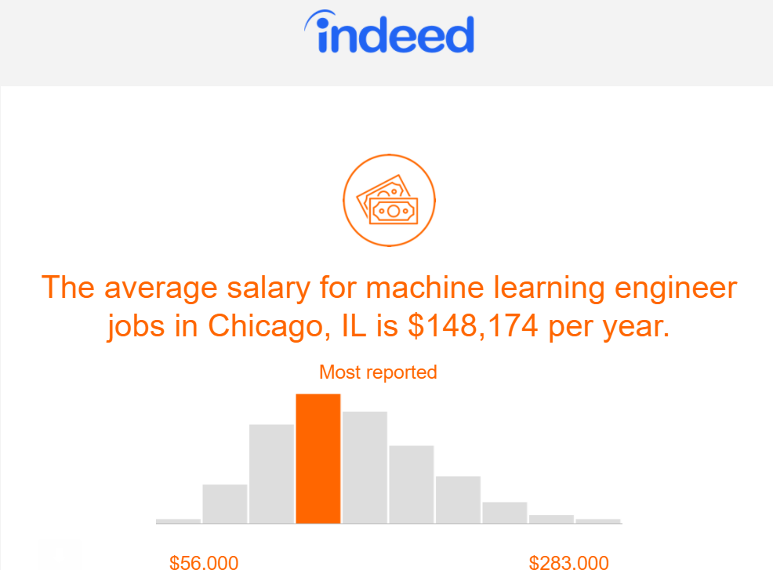

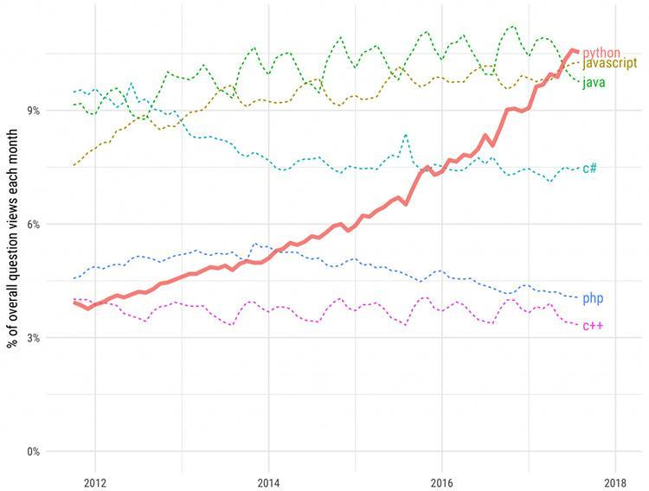

## Git and GitHub

### GitHub

<https://github.com/>

GitHub is a development platform inspired by the way you work. Users can host and review code, manage projects, and build software alongside millions of other developers.

* GitHub is a repo **hosting** and **sharing** site.
* GitLab bitbucket offer similar service, but these git services are all based on the tool git.

### Git

<https://git-scm.com/>

Git is a free and open source **distributed** *version control system* designed to handle everything from small to very large projects with speed and efficiency.

* Git is the tool.
* What is version control
* Git folder and Git ignore
* Branch. Local branch and remote branch
* Distributed version control system. (remote and locals)
* Git commands (init colon branch commit)

|  |
| --- |
| On server:  mkdir my_project.git  cd my_project.git  git --bare init  On client:  mkdir my_project  cd my_project  touch .gitignore  git init  git add .  git commit -m "Initial commit"  git remote add **origin** youruser@yourserver.com:/path/to/my_project.git  git push origin master |

### Git Desktop Application

* GitHub Desktop <https://desktop.github.com>
* Git Kraken <https://www.gitkraken.com>

### GitHub Page for a Portfolio Site

* Follow <https://pages.github.com/>
* Create a new repository named username.github.io, where username is your username (or organization name) on GitHub. The username is **case sensitive** and please use all **small** letters.
* Adding the index.html to the root folder of the repo for main page. Index.html should be all **small letters** as well. You can keep README.md

### Python Setup

#### Python version

* Using python 3.x
* Difference from python 2 and python 3
  + Syntax difference such as print () vs print, xrange() vs range(), // vs /
  + Performance: Python 3 using lazy loading, fixed a lot of performance issue.
  + Library rearrange: such as in python3 we need to import functools for reduce()
  + __future__
    - from __future__ import division
    - from __future__ import print_function

#### Tools

* Python 3
* Anaconda
* Jupyter Notebook/ Jupyter lab
* PyCharm

#### Virtual Environment

* Make device wide environment clean and make sure no conflicts libraries.
* Make sure project use required version of library.
* To Install it: **pip install virtualenv**
* To Use it you need to activate the virtualenv first.
* Your IDE can help creating a Virtual Environment

#### On Mac/Linux

* + $ virtualenv ENV
  + $ source bin/activate
  + $ deactivate

#### On Windows, the equivalent *activate* script is in the Scripts folder:

**>** \path\to\env\Scripts\activate

### Review Python

Python is a **dynamic**, **interpreted** (bytecode-compiled) language. There are **no type declarations** of variables, parameters, functions, or methods in source code. The code is short and flexible, and there is **no compile-time type checking** of the source code. Python tracks the types of all values at **runtime** and flags code that does not make sense as it runs.

#### Python source code (.PY)

Python **source files** use the ".py" extension and are called "modules." With a Python module hello.py, the easiest way to run it is with the shell command "**python** hello.py Alice" which calls the Python interpreter to execute the code in hello.py, passing it the command line argument "Alice".

#### Indentation Style

* This is different from the c-style languages. Such as C++, c#, java, JavaScript, which using {}
* Indentation made the code looks like a pseudo code. Python is runnable pseudo code
* Made the code clean and easy to read
* : usually used at the end of the line with indentation
* strings have a lot built-in function. How to master them? Practice and practices.

#### Number

* Consider the python as a calculator
* Float and int

#### String

* Types of Sting in Python
  1. Utf-8 String
  2. B String
* Using single or double quotation marks.

#### List

* Declared by brackets “[]”
* Can hold multiple types of variables

### Python

#### Control Flow

In this universe, anything can be done by these **three ways**.

* Step by Step: line by line
* Branch: if… elif… else..
* Looping: for, while

#### Coding Practices:

1. Find the second max number of a list
2. Check if a list is sorted
3. Check if a number is a cube number, such as 1, 8, 27, 64….

#### Functions

* Built-in Functions
* User-defined Functions
* Functions in Python sample, please learn by heart.

**# Defines a "repeat" function that takes 2 arguments.  
def repeat(s, exclaim):  
    """  
    Returns the string 's' repeated 3 times.  
    If exclaim is true, add exclamation marks.  
    """**

**result = s + s + s # can also use "s * 3"  
    if exclaim:  
        result = result + '!!!'  
    return result**

* Functional programming

Now, let’s consider the following functional style:

**def square(x):**

**return x*x**

**a_list =[1,2,3,4]**

**output = map(square, a_list)**

**print(list(output))**

* Lambda
* Map, Reduce, Filter

### Review HTML/CSS

#### Html5 Basic Template

<!doctype html>

<html lang="en">

<head>

<meta charset="utf-8">

<title>The Title</title>

<meta name="description" content="The Key Word">

<meta name="author" content="Your Name">

<link rel="stylesheet" href="css/styles.css">

</head>

<body>

<script src="js/scripts.js"></script>

</body>

</html>

#### The HTML DOM (Document Object Model)

The Document Object Model (DOM) is an application programming interface (API) for valid HTML. It defines the logical structure of documents and the way a document is accessed and manipulated.

When a web page is loaded, the browser creates a **D**ocument **O**bject **M**odel of the page.

The **HTML DOM** model is constructed as a tree of **Objects**:

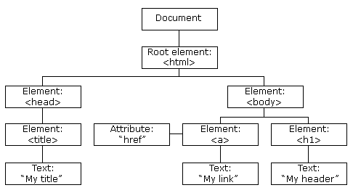

#### What is the HTML DOM?

* The HTML DOM is a standard **object** model and **programming interface** for HTML. It defines:
* The HTML elements as **objects**
* The **properties** of all HTML elements
* The **methods** to access all HTML elements
* The **events** for all HTML elements

In other words:**The HTML DOM is a standard for how to get, change, add, or delete HTML elements.**

#### CSS with DOM

DOM + CSS = A beautiful couple! Html is the skeleton, CSS tells the browser how to display each node of the html.

#### 3 ways to style a DOM node

* Inline
* On the page
* Reference from separate files

#### Query

* class
* id
* tag name

#### Box model

The CSS Box Model and CSS Positioning are two fundamental concepts in web design. Understanding these concepts is essential to mastering page layout and other web design issues.

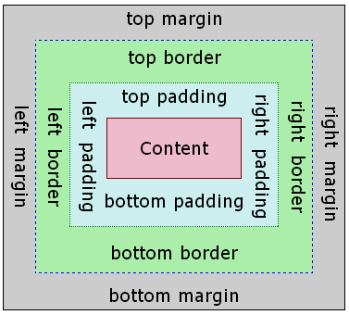

#### JavaScript with DOM

With the object model, JavaScript gets all the power it needs to create **dynamic** HTML:

* JavaScript can change all the HTML elements in the page
* JavaScript can change all the HTML attributes in the page
* JavaScript can change all the CSS styles in the page
* JavaScript can remove existing HTML elements and attributes
* JavaScript can add new HTML elements and attributes
* JavaScript can react to all existing HTML events in the page
* JavaScript can create new HTML events in the page

### Introduction to Network and Web development

#### Network

* Layers

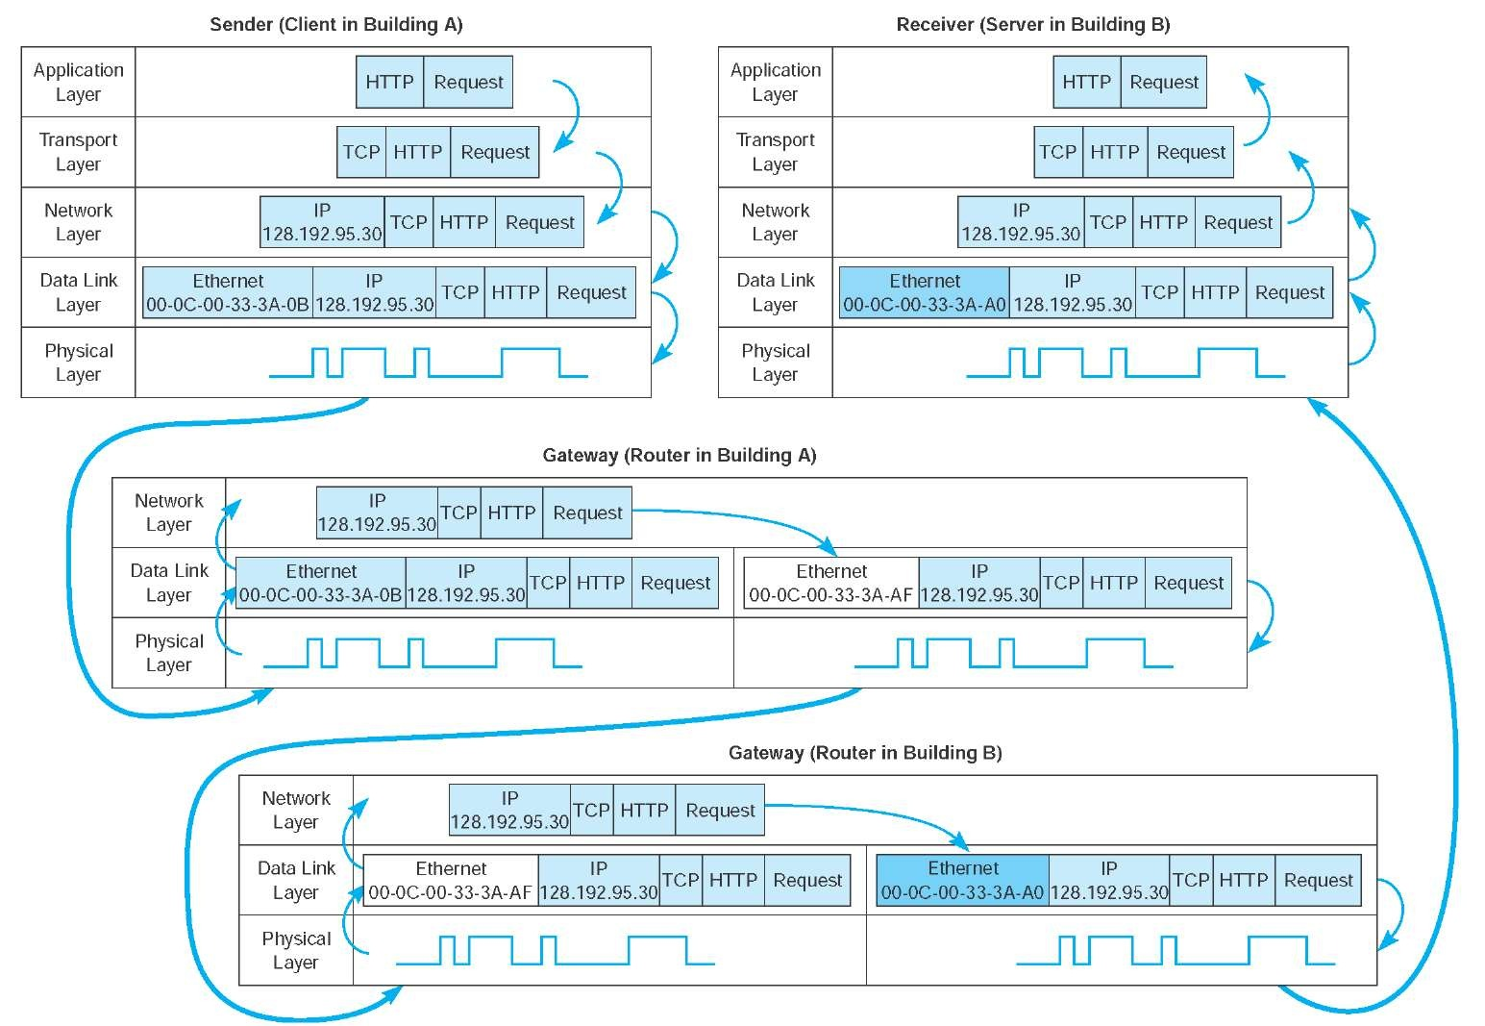

#### HTTP Hypertext Transfer Protocol

Http is an application protocol for distributed, collaborative, and hypermedia information systems. HTTP is the foundation of data communication for the World Wide Web.

* Http is at the top layer
* Http protocol has two parts head and the body

#### Http status codes

* 200
* 300
* 400
* 500

#### HTTP Methods

HTTP (the protocol web applications are speaking) knows different methods for accessing URLs. By default, a route only answers to GET requests, but that can be changed by providing the methods argument to the route() decorator.

from flask import request

@app.route('/login', methods=['GET', 'POST'])

def login():

if request.method == 'POST':

do_the_login()

else:

show_the_login_form()

The HTTP method (also often called “the verb”) tells the server what the client wants to do with the requested page. The following methods are very common:

#### GET

The browser tells the server to just get the information stored on that page and send it. This is probably the most common method.

The Query String Parameter will be in the URL.

#### POST

The browser tells the server that it wants to post some new information to that URL and that the server must ensure the data is stored and only stored once. This is how HTML forms usually transmit data to the server.

Form data Parameters will NOT be in the URL.

#### PUT

Like POST but the server might trigger the stored procedure multiple times by overwriting the old values more than once. Now you might be asking why this is useful, but there are some good reasons to do it this way. Consider that the connection is lost during transmission: in this situation a system between the browser and the server might receive the request safely a second time without breaking things. With POST that would not be possible because it must only be triggered once.

#### HEAD

The browser tells the server to get the information, but it is only interested in the headers, not the content of the page. An application is supposed to handle that as if a GET request was received but to not deliver the actual content. In Flask you don’t have to deal with that at all, the underlying Werkzeug library handles that for you.

#### DELETE

Remove the information at the given location.

### URL

A Uniform Resource Locator (URL), colloquially termed a web address, is a reference to a web resource that specifies its location on a computer network and a mechanism for retrieving it.

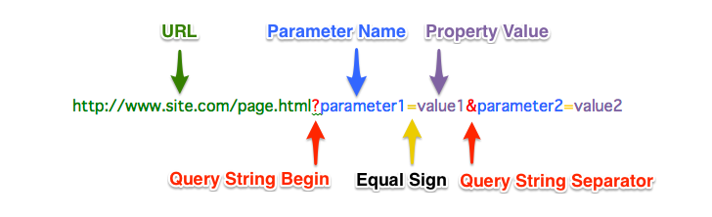

### Client and Server Model

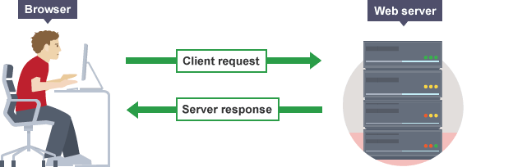

### DNS

The Domain Name System is a hierarchical decentralized naming system for computers, services, or other resources connected to the Internet or a private network.

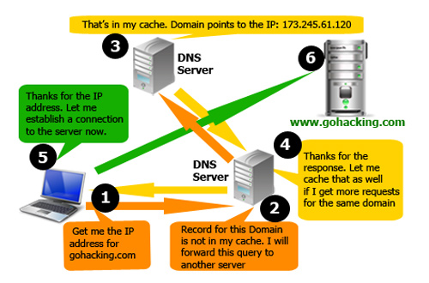

Web Form

<form action="https://.... " method="get">

Name: <input type="text" name="name">

pass: <input type="password" name="pass">

<input type="submit">

</form>

<form action="https://.... " method="post">

Name: <input type="text" name="name">

pass: <input type="password" name="pass">

<input type="submit">

</form>

### Chrome Inspector Network tab

Get Method

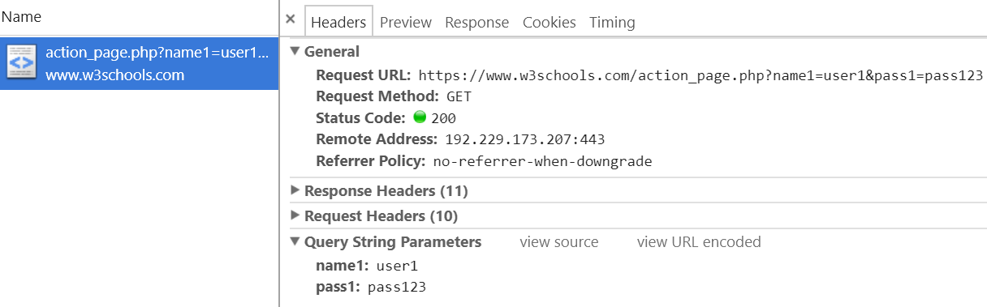

Post Method

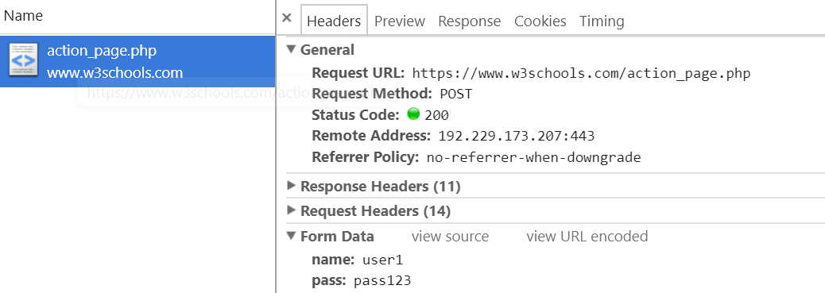

### Common ways to fire a network request

* URL request
* Refresh pages
* Form submits
* Ajax call

There are other ways, but for now remember the 4 common ways.

### Bootstrap v4

Bootstrap is an open source toolkit for developing with HTML, CSS, and JS. Quickly prototype your ideas or build your entire app with our Sass variables and mixins, responsive grid system, extensive prebuilt components, and powerful plugins built on jQuery.

The official site <https://getbootstrap.com/>

#### Importing

Using CDN or Local

<link rel="stylesheet" href="https://maxcdn.bootstrapcdn.com/bootstrap/4.0.0/css/bootstrap.min.css">

<script src="https://maxcdn.bootstrapcdn.com/bootstrap/4.0.0/js/bootstrap.min.js"> </script>

#### The process

The Process can be broken down into five (easy) steps:

1. wireframe your project
2. choose a template
3. go shopping on the components page
4. paste components onto your page
5. add some custom frosting on your cupcake

#### Responsive Design

* No fixed width>300px, using percentage in CSS
* Try not to use absolute position
* Media Query (@media is the Media Query)

@media not|only *mediatype*and(*expressions*) { *CSS-Code;*}

**Mediatype**:

all, print, screen, speech

**Example**:

@media screen and (min-width: 480px) {  
    #leftsidebar {width: 200px; float: left;}  
    #main {margin-left: 216px;}  
}

* Responsive breakpoints
* To ensure proper rendering and touch zooming for all devices, **add the responsive viewport meta tag** to your <head>

<meta name="viewport" content="width=device-width, initial-scale=1, shrink-to-fit=no">

#### LAYOUT

##### Containers

* most layouts do not require a nested container.
* Two mainly used containers classes in Bootstrap

**.container** fixed-width container (meaning its max-width changes at each breakpoint)

**.container-fluid** fluid-width (meaning it’s 100% wide all the time)

##### Grid system

Use our powerful mobile-first flexbox grid to build layouts of all shapes and sizes thanks to

* **Twelve-column** system
* **Five** default **responsive tiers**
* Sass variables and mixins
* dozens of **predefined classes.**

##### COMPONENTS

Predefined HTML competent. They are common used in web pages with specific user cases.

Alerts, Badge, Breadcrumb, Buttons, Button group, Card, Carousel, Collapse, Dropdowns, Forms, Input group, Jumbotron, List group, Modal, Navs, Navbar, Pagination, Popovers, Progress, Scrollspy, Tooltips

##### Buttons

Use Bootstrap’s custom button styles for actions in forms, dialogs, and more with support for multiple sizes, states, and more.

##### Cards

Bootstrap’s cards provide a flexible and extensible content container with multiple variants and options.

##### Carousel

A slideshow component for cycling through elements—images or slides of text—like a carousel.

##### Collapse

Toggle the visibility of content across your project with a few classes and our JavaScript plugins.

##### Modal

Use Bootstrap’s JavaScript modal plugin to add dialogs to your site for lightboxes, user notifications, or completely custom content.

##### Popovers

Documentation and examples for adding Bootstrap popovers, like those found in iOS, to any element on your site.

### UTILITIES (Predefined CSS class)

#### Display property

Quickly and responsively toggle the display value of components and more with our display utilities. Includes support for some of the more common values, as well as some extras for controlling display when printing.

#### Position

Use these shorthand utilities for quickly configuring the position of an element.

#### Clearfix

Quickly and easily clear floated content within a container by adding a clearfix utility.

#### Float (was pull)

Toggle floats on any element, across any breakpoint, using our responsive float utilities.

#### Flex (not a good practice before because of IE, but get popular now)

Quickly manage the layout, alignment, and sizing of grid columns, navigation, components, and more with a full suite of responsive flexbox utilities. For more complex implementations, custom CSS may be necessary.

### Advanced CSS

Although CSS allows you to style pages and even entire sites with a single page, it can also do much more than just design. Advanced topics of CSS cover animation, transforms, and browser compatibility through media tags. Using these advanced topics you can make a web application come to life and be mobile optimized.

#### Browser Support

Each browser supports different CSS implementations on their own versions. Below is a way to support transform animations on four different browsers. Using these declarations you can be sure that the animations either work correctly or show without animation, otherwise they most likely wouldn’t appear in the browser.

* [List of browser compatibility for each version.](https://www.w3schools.com/cssref/css3_browsersupport.asp)

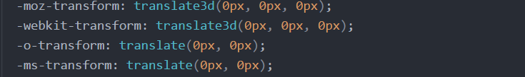

#### Animations/Keyframes

CSS3 incorporated animations without the hassle of using Javascript or Flash. While you’ll need to use browser compatibility tags, most browsers today support the use of these animations.

The @keyframes rule

* Declare from/to
  + Percentages allowed
    - i.e. - 0%, 25%, 50%, 75%, 100%
* Given Name

@keyframes my_example {

from { background-color: red; }

to { background-color: blue; }

}

Using the keyframes declaration

* Declaring “Animation Name”
* Setting an animation duration
  + Defined in seconds

div {

animation-name: my_example;

animation-duration: 4s;

}

#### Transforms

CSS transforms allow you to translate, rotate, scale, and skew elements. With transforms you can alter the shape, size, and position of an element.

There are two kinds of transforms:

1. 2D
2. 3D

Key functions when using transforms:

* translate()
* rotate()
* scale()
* skewX()
* skewY()
* matrix()

#### Media Tags

The @media tag was created in CSS2 and re-implemented in CSS3 to allow for different styles based on the device a user was on. Media queries can be used to check many things, such as:

* Width and Height of the Viewport
* Width and Height of the Device
* Orientation (landscape/portrait)
* Resolution

Media queries allow for better styling on mobile devices by defining a certain screen width.

@media screen and (min-width: 480px) {

body {

background-color: lightgrey;

}

}

In the example above any device with a screen width below or equal to 480px will now have a background-color of lightgrey (which may be different than the defined background-color for other devices).

**One thing to note about media tags is that any stylings within that tag will overwrite the previous styles in the file.**

### Mobile Optimization

Responsive Layout

Bootstrap comes with a built-in a mobile optimization system.

<div class="container”>

<div class="row">

<div class="col-sm">

One of three columns

</div>

<div class="col-sm">

One of three columns

</div>

<div class="col-sm">

One of three columns

</div>

</div>

</div>

Inside every row exists lies the ability to create however many columns necessary. With the

Bootstrap v4 update, we no longer need to specify how many columns to allocate to a row. It

calculates, on its own how much space to allocate to compensate for 12 columns width.

Optimizing the layout for a specific device is as easy as specifying which screen you need to.

* xl - large TV monitor
* lg - desktop screen
* md - laptop screen
* sm - mobile screen
* xs - small mobile screen

# 

# Week 2 - Python Basic

**Monday**

* Introduction to Python
* Basic Elements
  + Variable Assignment - Draw variable memory assignment
  + Control Flows - Loops & Conditional Statements
  + String Input/Output
* **Exercise:** 
  + Sort a list
  + Get first 100 Prime numbers
  + Cube number test

**Tuesday**

* Functions and Scoping
* Data Collections I (Tuples, Lists, Strings)
* List Comprehensions
* **Exercise:** 
  + Merge two sorted array/list.
  + Bubble sorting

**Wednesday**

* Data Collections II (Dictionary, Set)
* Intro Modules and Importing System
* **Exercise**:
  + Importing and Creating own Module
* **Project**: Create a basic shopping cart application

**Thursday**

* Object-Oriented Programing (OOP)
  + The ‘self’ keyword
  + Access properties and methods
  + Instantiation
* **Exercise**:
  + Re-do shopping cart application using object-oriented programming principles

**Friday**

* **Project**: Create a Hangman game using OOP
* **Weekend Challenge**:
  + Finish Hangman

## 

## Extra Reading

### 

### Computer Science and Programming Language

Computer science is the study of the theory, experimentation, and engineering that form the basis for the design and use of computers.

### Why it’s called a language

* Natural language such as English is some tradition everyone agreed, use to exchange ideas among people.
* Programming language is designed for people communicate with computer hardware.

### Languages

From the low level to high level

* Machine code
* Assembly language
* C, C++
* Java, C#, swift
* Python, R, JavaScript, PHP

### Low level Programming

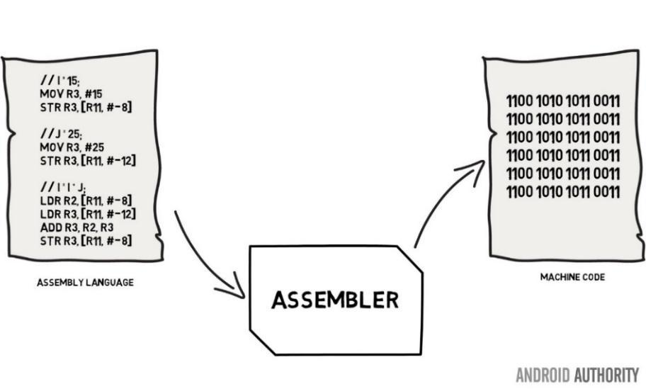

(form Android Authority)

### RAM and CPU

#### RAM

Computer memory is any physical device capable of storing information temporarily. Memory is usually used to refer **Random** **Access** **Memory** (RAM). CPU and other hardwares using the address to access a content stored in RAM.

<http://computerscience.chemeketa.edu/cs160Reader/ComputerArchitecture/Memory.html>

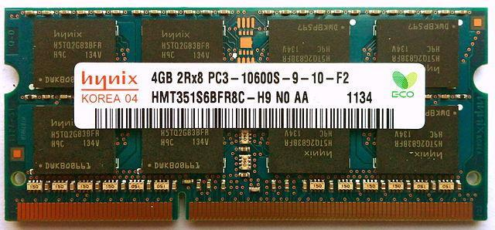

#### Address and Value

In computing, a memory address is a reference to a specific memory location used at various levels by software and hardware. Memory addresses are fixed-length sequences of digits conventionally displayed and manipulated as unsigned integers. Such numerical semantic bases itself upon features of CPU (such as the instruction pointer and incremental address registers), as well upon use of the memory like an array endorsed by various programming languages.

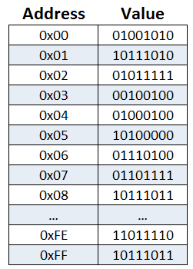

#### CPU

A **central processing unit** is the electronic circuitry within a computer that carries out the instructions of a computer program by performing the basic arithmetic, logical, control and input/output operations specified by the instructions.

#### Introduction to Python

### Facts

* Python is a very active language. It was introduced by Guido van Rossum in 1990,
* It is an easy language to use. Feedback from programmer is always top.
* Python is general purpose programming languages. Different from SQL.
* Weak static checking, which is different from C#, Java, C++
* Python uses **indentation** for control flow. It makes Python like pseudo code.
* Do **NOT** use Python 2 anymore!
* Use a python like a vehicle, and not reinventing the wheel.

However, for learning python, we need to know how to make wheel. and always go deeper to find the root reason.

#### Comparing

(from INTRODUCTION TO COMPUTATION AND PROGRAMMING USING PYTHON)

* **Low-level versus high-level** refers to whether we program using instructions and data objects at the level of the machine (e.g., move 64 bits of data from this location to that location) or whether we program using more abstract operations (e.g., pop up a menu on the screen) that have been provided by the language designer.
* **General versus targeted to an application domain** refers to whether the primitive operations of the programming language are widely applicable or are fine tuned to a domain. For example, SQL is designed to facilitate extracting information from relational databases, but you wouldn’t want to use it build an operating system.
* **Interpreted versus compiled** refers to whether the sequence of instructions written by the programmer, called source code, is executed directly (by an interpreter) or whether it is first converted (by a compiler) into a sequence of machine-level primitive operations. (In the early days of computers, people had to write source code in a language that was very close to the machine code that could be directly interpreted by the computer hardware.) There are advantages to both approaches. It is often easier to debug programs written in languages that are designed to be interpreted, because the interpreter can produce error messages that are easy to correlate with the source code. Compiled languages usually produce programs that run more quickly and use less space.

### Basic Elements

#### Expression

Python is a big **calculator**. Expression is just like you use a calculator.

#### Object Types

* Non-Scalar object (instance of **Class**)
* Scalar object (**Python has four types of scalar objects**)
* int
* float
* bool
* None

#### Variable Assignment

Variables provide a way to associate names with objects. Consider the code

pi = 3

radius = 11

area = pi * (radius**2)

radius = 14

It first binds the names pi and radius to different objects of type int.10 It then binds the name area to a third object of type int. This is depicted in the left panel

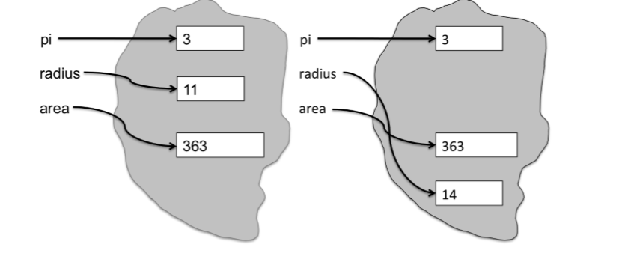

A visualizing python programming website <http://pythontutor.com>

#### Control Flows

Python uses **indentation** for control flow. It makes Python like pseudo code. Learn more it, please check the official document: <https://docs.python.org/3/tutorial/controlflow.html>

* **break** and **continue** Statements, and **else** Clauses on Loops
* The **range ()** Function
* **pass** Statements

#### The three ways

1. Line by Line
2. Branching
3. Iteration

### Function and Scoping

#### Built-In Function

The Python **interpreter** has several pre-defined functions built into it.

#### User-Defined Function

A function definition defines a user-defined **function object**. Using def(parameters):

def func(x, y = 2):

return x+y

A function definition can specify a return statement

### Parameters

A parameter is a named entity in a function definition that specifies an argument that the function can accept.

#### Default value

Functions may specify a **default value** for one or more arguments.

def my_func(x, y = 2, z=0):

print(x, y, z)

#### Variable Arguments

Functions may accept a variable number of arguments using the * operator to pass a list.

def sum(*args):

total = 0

for arg in args:

total += arg

return total

#### Variable named arguments

Functions may be accessed using the ** operator to pass a dict.

def keywords(**kwargs):

for item in kwargs.items():

print(item)

#### Docstring

Use """triple double quotes""" to document the function. Use __doc__ to get the docstring.

def my_func(parameter):

"""This docstring documents the function."""

pass

print(my_func.__doc__)

### Basics of Data structure I (String, Tuples, List)

#### 0-based indexing

* Most computer science oriented programming languages use 0-based index.
* R and Matlab use 1-based indexing

*There are three basic sequence types:* ***tuple****,* ***lists*** *and* ***range*** *object*

#### Tuple

* A Python tuple consists of a list of **none** or **one** or **more** elements.
* Python tuple is written as a sequence of numbers enclosed in ***round* parentheses** and separated by **commas**.
* Python tuple is ***immutable***. You cannot change it after created. If you do assignment like c [2] = 17 you get this error: 'tuple' object does not support item assignment

**t = (1, 1, 2, 3, 5, 8, 13)**

#### List

* A Python List consists of a list of **none** or **one** or **more** elements.
* Python List is defined by a pair of***square* brackets** on either **end** with individual elements separated by **commas**.
* Python list is ***mutable***. You can update values of elements in a list. You can do appending, pop…
* **Heterogeneous**

**l = [0, 1, 1, 2, 3, 5, 8, 13]**

#### range

* The range type represents an immutable sequence of numbers and is commonly used for looping a specific number of times in for loops.
* Example:
  + range(len(a_list))
  + range(2,10)
  + range(len(a_list)-1, -1, -1)

### String

* Double or Single paired quotation marks
* Mostly like a list but immutable.
* Python string has a lot of built-in functions.

### Indexing

* a[1]
* a[2]=3
* a[-1]

### Slicing

* Create a subset of a list by specifying two indices separated by a colon “:”
* a [: 3] What does this slice give? a [2:] What does this slice give?
* a [1: -1] What does this slice give?
* a [: :-1] get a new created reverse list

## Immutable and mutable

Some objects are mutable, meaning they can be altered. Others are immutable; they cannot be changed but rather return new objects when attempting to update.

The way to remember which types are mutable and which are not is that containers and user-defined types tend to be mutable while scalar types are almost always immutable. Then remember some notable exceptions: tuple is an immutable container, **frozenset** is an immutable version of set. Strings are immutable; what if you want to do some in-place modifications like character swapping? Use a **bytearray**.

### Common immutable objects:

* int
* float
* decimal
* complex
* bool
* string
* tuple
* range
* frozenset
* bytes

### Common mutable objects:

* list
* dict
* set
* bytearray
* user-defined classes (unless specifically made immutable

## Basics of Data Structure II Hash; Dictionary and Set

Hash is one of the gems of computer science.

### Hash function

* A hash function is any function that can be used to map data of arbitrary size to data of fixed size.
* Hash is based on **value** not the object! Same value will get the same hash even if it's not the same object.
* Python has built-in hash function: **hash ()**

>>> hash ("Look at me!")

4343814758193556824

>>> f = "Look at me!"

>>> hash (f)

4343814758193556824

* A hash function may get collision issue. For example this hash function maps names to integers from 0 to 15. There is a collision between keys "John Smith" and "Sandra Dee".

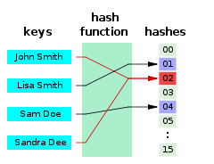 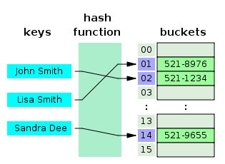

### Hash table

In computing, a hash table (hash map) is a data structure which implements an associative array abstract data type, a structure that can map keys to values. A hash table uses a hash function to compute an index into an array of buckets or slots, from which the desired value can be found.

Hash Table time complexity in big O notation

|  |  |  |
| --- | --- | --- |
| **Algorithm** | **Average** | **Worst case** |
| **Space** | O(*n*) | O(*n*) |
| **Search** | O(1) | O(*n*) |
| **Insert** | O(1) | O(*n*) |
| **Delete** | O(1) | O(*n*) |

Python **Dictionary** and **Set** are bested on hash table. Hash concept is super important and must fully understand.

### Dictionary

Dictionaries are collections that are indexed by keys, which can be any immutable type. It is best to think of a dictionary as an unordered set of key and value pairs, with the requirement that the keys are unique (within a dictionary).

dictionary = {

'lisa': '521-8976',

'john': '521-1234',

}

dict2 = {} # mutable

dict2 ['cat'] = 101293889732 # set

print (dict2 ['cat']) # get

#### Dictionary looping:

* Only looping the key

for key in d:

print(key)

* looping the key and value

for key, value in d**.**items**()**:

print(key, value)

#### Sorting by Key

* Dictionaries are unordered. Dictionary items may be displayed in key order by sorting a list of keys using the sorted() function and the dictionary.keys() method.

for key in sorted(dictionary.**keys**()):

print("dictionary[%s]: %s" % (key, dictionary[key]))

#### Sorting by Value

* Dictionaries are unordered. Dictionary items may be displayed in value order by sorting a list of key-value pairs using the sorted() function and the dictionary.get() method.

for key in sorted(dictionary, key=dictionary.**get**):

print("dictionary[%s]: %s" % (key, dictionary[key]))

#### Multidimensional (nested) Dictionaries

dictionary = {

'John': {'name': 'John Smith', 'phone': '123-555-0101'},

'Jose': {'name': 'Jose Garcia', 'phone': '123-555-0102'}

}

#### Dictionary as Return Value (for multiple value return)

return {'x': 12, 'y': 45, 'y': 78}

### Set

A set object is an **unordered** collection of **distinct** hashable objects.

Set is a dictionary without values

#### Common uses

* Membership testing
* Removing duplicates from a sequence
* Computing mathematical operations such as intersection, union, difference, and symmetric difference.

#### Methods

* Support x in set, **len(set)**, and for x in set.
* As an unordered collection, sets do not record element position or order of insertion.
* Set does not support indexing, slicing, or other sequence-like behavior.
* Set type is mutable. Contents can be changed using methods like **add ()** and **remove ()**.
* Since it is mutable, **set itself has no hash value** and cannot be used as either a dictionary key or as an element of another set.

#### [Frozenset](https://docs.python.org/3.6/library/stdtypes.html#frozenset)

There are currently two built-in set types, [set](https://docs.python.org/3.6/library/stdtypes.html#set) and [frozenset](https://docs.python.org/3.6/library/stdtypes.html#frozenset). The [frozenset](https://docs.python.org/3.6/library/stdtypes.html#frozenset) type is immutable and [hashable](https://docs.python.org/3.6/glossary.html#term-hashable) — its contents cannot be altered after it is created; it can therefore be used as a dictionary key or as an element of another set.

#### Remove duplication and built-in set() function

a_list = [1, 1, 1]

a_tuple = (1, 1, 1)

print("list:", a_list)

print("set:", set(a_list))

print("tuple:", a_tuple)

print("set:", set(a_tuple))

### List, tuple, dict and set

a_list = ["fish", "dog", "cat"]

a_tuple = ("fish", "dog", "cat")

a_dict = {

'fish': 'Bubbles',

'dog': 'Spot',

'cat': 'Frisky',

}

a_set = {"fish", "dog", "cat"}

### Empty sequences and collections

**'', (), [], {}, set (), range (0)**

### Modules and Importing System

#### Module

A module is a **py file.** Such as a file circle.py

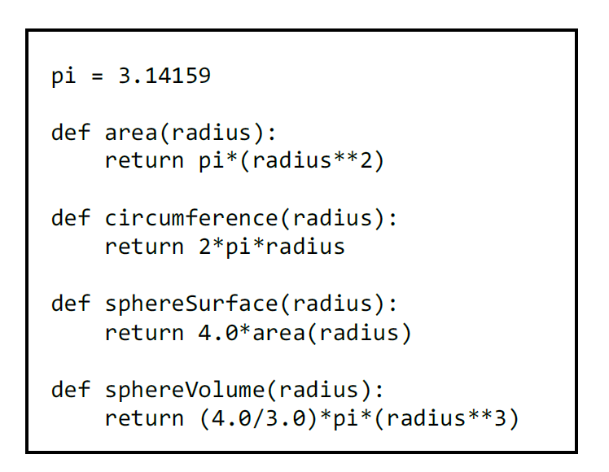

#### Importing

A program gets access to a module through an import statement.

import circle

pi = 3

print(pi)

print(circle.pi)

print(circle.area(3))

print(circle.circumference(3))

print(circle.sphereSurface(3))

>> 3

3.14159

28.27431

18.849539999999998

113.09724

#### from

A variant of the import statement that allows the importing program to omit the module name when accessing names defined inside the imported module. Executing the statement from M import * creates bindings in the current scope to all objects defined within M, but not to M itself.

from circle import *

print(pi)

#### as

Just for shortcut

from sklearn.tree import decisiontreeclassifier as dtree

### Object-Oriented Programing (Class and Object)

#### History

The ideas underlying object-oriented programming are about 50 years, and have been widely accepted and practiced over the last 25 years.

Firstly, Small talk. Got popular with C++, Objective C. Even popular with Java, C#

#### Why OO and Abstract Data Types

* For implementing a complicated idea, to group data and methods become a difficult task without using Object-Oriented Programming.
* OO put **data attributes** and **method attributes** put **together**.
* An abstract data type is a set of **objects** and the **operations** on those objects. These are bound together so that one can pass an object from one part of a program to another, and in doing so

provide access not only to the data attributes of the object but also to operations that make it easy to manipulate that data.

#### Decomposition and Abstraction.

* Programming is about managing complexity in a way that facilitates change.
* Decomposition creates structure in a program.
* Abstraction suppresses detail.

#### Class and Object

* Classes represent real-world item will be coded in your programs: Ex, dogs, cars, and robots.
* We can use a class to make objects, which are specific **instances** of dogs, cars, and robots.
* A class defines the general behavior that a whole category of objects can have, and the

information that can be associated with those objects.

* Classes can inherit from each other class.

#### Syntax

**class Person:**

**def __init__(self, name):**

**self.name = name**

**class Employee (Person): # Employee is a Person**

**empCount = 0 # Common base class for all employees**

**def __init__(self, name, salary):**

**self.salary = salary # Only for this creating Employee**

**Employee.empCount += 1**

**super().__init__(name)**

**def displayCount(self):**

**print("Total Employee", Employee.empCount)**

**def __str__(self):**

**return "Name : "+ str(self.name) + ", Salary: "+ str(self.salary)**

**emp = Employee("TOM CAT", 5000)**

#### Self parameter

The object associated with the expression preceding the dot is implicitly passed as the first parameter to the method.

#### Class variable vs instance variable

* self.xxx instance variable
* without self is Class variable.

#### Specially named method

* __init__ ( self [,args...] )

#### Constructor (with any optional arguments)

* __del__( self )

Destructor, deletes an object

* __str__( self )

Printable string representation

….

#### Inheritance

* Add new attributes, both method attributes and data attributes
* Override a parent method
* Use super() to call the parent class. Also, can apply to constructor such as super().__init__()

class A:

def output(self):

print('output A')

class B(A):

def output(self):

print('output B')

super().output()

b=B()

b.output()

#### Overloading Operators

Redefine the **__add__** method in the class to perform vector addition, the + operator overloaded.

class Vector:

def __init__(self, a, b):

self.a, self.b = a,b

def __add__(self,other):^M

return Vector(self.a + other.a, self.b + other.b)

v1 = Vector(2,10)

v2 = Vector(5,-2)

(v1+v2).a, (v1+v2).b

## 

### Comprehensions

#### LIST Comprehensions

A list comprehension consists of the following parts:

* An Input Sequence.
* A Variable representing members of the input sequence.
* An Optional Predicate expression.
* An Output Expression producing elements of the output list from members of the Input Sequence that satisfy the predicate.

Example: obtain a list of all the integers in a sequence and then square them:

a_list = [1, ‘4’, 9, ‘a’, 0, 4]

squared_ints = [ e**2 for e in a_list if type(e) == types.IntType ]

squared_ints

# [ 1, 81, 0, 16 ]

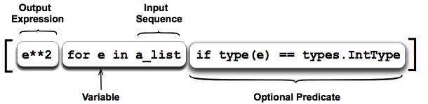

#### 2D List Comprehensions

[[x+y/10 for x in range(5)] for y in range(3)]

[[0.0, 1.0, 2.0, 3.0, 4.0],

[0.1, 1.1, 2.1, 3.1, 4.1],

[0.2, 1.2, 2.2, 3.2, 4.2]]

**Question**: what is the difference

* [[0]*10]*4
* [ [0]*10 for _ in range(4)]

#### SET Comprehensions

{n**2 for n in range(10)}

#### DICT Comprehensions

{x: x**2 for x in range(10)}

### Introduce Algorithmic Complexity

An important question is: How efficient is an algorithm or piece of code?

#### Algorithmic Complexity

* Constant time
* N Time
* N*N Time
* LogN Time

#### Big-O Notation

Express complexity using **big-O notation**. For a problem of size N:

* a constant-time method is "order 1": O (1)
* a linear-time method is "order N": O (N)
* a quadratic-time method is "order N squared": O (N2)

# Week 3 - Advanced Python

**Monday**

* Advanced Object-Oriented Programming
  + Creating Multiple Instances through Loops
  + Magic Methods
  + Object Inheritance
  + Method Overriding
  + Inheriting Multiple Classes
* **Exercise:** 
  + **Dungeon Monsters**

**Tuesday**

* Map, Reduce, Filter, and Lambda
* Recursive Functions
* **Extra**: Generator and Iterator
* **Exercise:** 
  + **Map/Filter**
  + **Fibonacci Sequence**

**Wednesday**

* Intro to Regular Expressions
* Merge two sorted arrays and Merge sort
* **Exercise**:
  + **Regular Expression Exercise**

**Thursday**

* Binary Search
* Introduction to Dynamic programming/Memoization
* Decorators

**Friday**

* **Project:** BlackJack (OOP)
* **Weekend Challenge**:
  + Finish BlackJack (commit)

## 

## 

## 

## Extra Reading

### Advanced data structure

#### Python Collections

This module implements specialized container datatypes providing alternatives to Python’s general purpose built-in containers, dict, list, set tuple.

|  |  |
| --- | --- |
| [namedtuple()](https://docs.python.org/3.6/library/collections.html#collections.namedtuple) | factory function for creating tuple subclasses with named fields |
| [**deque**](https://docs.python.org/3.6/library/collections.html#collections.deque) | list-like container with fast appends and pops on either end |
| [ChainMap](https://docs.python.org/3.6/library/collections.html#collections.ChainMap) | dict-like class for creating a single view of multiple mappings |
| [**Counter**](https://docs.python.org/3.6/library/collections.html#collections.Counter) | dict subclass for counting hashable objects |
| [OrderedDict](https://docs.python.org/3.6/library/collections.html#collections.OrderedDict) | dict subclass that remembers the order entries were added |
| [**defaultdict**](https://docs.python.org/3.6/library/collections.html#collections.defaultdict) | dict subclass that calls a factory function to supply missing values |
| [UserDict](https://docs.python.org/3.6/library/collections.html#collections.UserDict) | wrapper around dictionary objects for easier dict subclassing |
| [UserList](https://docs.python.org/3.6/library/collections.html#collections.UserList) | wrapper around list objects for easier list subclassing |
| [UserString](https://docs.python.org/3.6/library/collections.html#collections.UserString) | wrapper around string objects for easier string subclassing |

Reference

<https://docs.python.org/3.6/library/collections.html>

#### Most frequency used.

* deque
* Counter
* defaultdict

#### DEMOs

* Moving average Using deque
* Most common words in text using Counter
* Merge tags Using defaultdict with different data structure

#### LinkedList

* Compare the difference with Array List
* Single Linked List vs Double Linked List

#### Data Structure image

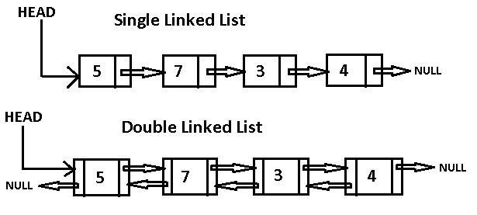

#### Python Code

# Definition for singly-linked list.

# class ListNode(object):

# def __init__(self, x):

# self.val = x

# self.next = None

#### Array vs LinkedList and Coding Practice

* <https://leetcode.com/tag/array/>
* <https://leetcode.com/tag/linked-list/>

#### Tree

#### Data structure

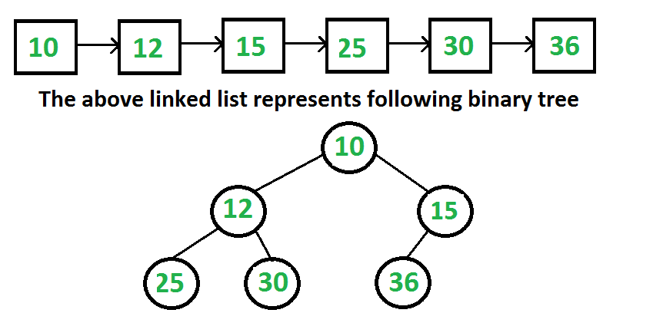

#### Python Code

# Definition for a binary tree node.

# class TreeNode(object):

# def __init__(self, x):

# self.val = x

# self.left = None

# self.right = None

#### Coding Practice

<https://leetcode.com/tag/tree/>

### Map, Reduce, Filter, and Lambda

#### Map

Map applies a function to all the items in an input list.

>>> list(map((lambda x: x **2), items))

[1, 4, 9, 16, 25]

#### Reduce

Reduce is a really useful function for performing some computation on a list and returning the result. It applies a rolling computation to sequential pairs of values in a list.

>>> reduce(lambda x,y: x+y, [47,11,42,13])

113

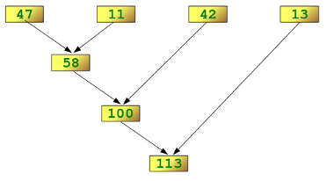

#### Filter

As the name suggests, filter creates a list of elements for which a function returns true.

>>> fib = [0,1,1,2,3,5,8,13,21,34,55]

>>> result = filter(lambda x: x % 2, fib)

[1, 1, 3, 5, 13, 21, 55]

>>> result = filter(lambda x: x % 2 == 0, fib)

[0, 2, 8, 34]

#### Lambda

The lambda operator or lambda function is a way to create small anonymous functions (functions without a name). These functions are throw-away functions. Lambda functions are mainly used in combination with the functions filter(), map() and reduce().

>>> f = lambda x, y : x + y

>>> f(1,1)

2

#### Reference

* <http://book.pythontips.com/en/latest/map_filter.html>
* <https://www.python-course.eu/lambda.php>
* <https://www.python-course.eu/lambda.php>

## 

### Recursion

* A function/method calls itself
* Termination condition
* Problem need to become smaller and smaller

#### Example I - factorial

n! = n * (n-1) * (n-2) * … * 2* 1

For example, if n =4 then 4! = 4 * 3 * 2 * 1. It can break down to…

4! = 4 * 3!  
3! = 3 * 2!  
2! = 2 * 1

def factorial(n):

if n == 1:

return 1

else:

return n * factorial(n-1)

QUESTION: why not just use for loop.

#### Example II – Fibonacci sequence

The Fibonacci numbers are the numbers of the following sequence of integer values:

The Fibonacci numbers are defined as:

Fn = Fn-1 + Fn-2

when F0 = 0 and F1 = 1

It is: 0,1,1,2,3,5,8,13,21,34,55, ...

##### Recursive way:

def fib(n):

if n < 2:

return n

else:

return fib(n-1) + fib(n-2)

##### For loop way:

def fib2(n):

a, b = 0, 1

for i in range(n):

a, b = b, a + b

return a

#### Example III – Same Tree

### RE – Regular Expression

A ***regular expression*** (regex) is, in theoretical computer science and formal language theory, a sequence of characters that define a **search** pattern.

Regex is very useful in computer science and data science. Also, it is top question be asked during the interview. Learn it in Python is the best approach, and you can transfer knowledge to other languages.

#### Import it

import re

#### Regular Expressions

* a, X, 9, < -- ordinary characters just match themselves exactly.
* . (a period) -- matches any single character except newline '\n'
* \w -- matches a "word" character: a letter or digit or underbar [a-zA-Z0-9_].
* \W -- matches any non-word character.
* \b -- matches word boundary (in between a word character and a non word character)
* \s -- matches a single whitespace character -- space, newline, return, tab
* \S -- matches any non-whitespace character.
* \t, \n, \r -- tab, newline, return
* \d -- matches any numeric digit [0-9]
* \D matches any non-numeric character.
* ^ -- matches the beginning of the string
* $ -- matches the end of the string
* \ -- escapes special character.
* (x|y|z) matches exactly one of x, y or z.
* (x) in general is a remembered group. We can get the value of what matched by using the groups() method of the object returned by re.search.
* x? matches an optional x character (in other words, it matches an x zero or one times).
* x* matches x zero or more times.
* x+ matches x one or more times.
* x{m,n} matches an x character at least m times, but not more than n times.
* ?: matches an expression but do not capture it. Non capturing group.
* ?= matches a suffix but exclude it from capture. Positive lookahead.
* a(?=b) will match the "a" in "ab", but not the "a" in "ac"
* In other words, a(?=b) matches the "a" which is followed by the string 'b', without consuming what follows the a.
* ?! matches if suffix is absent. Negative look ahead.
* a(?!b) will match the "a" in "ac", but not the "a" in "ab"
* ?<= positive look behind
* ?<! negative look behind

#### Methods

|  |  |
| --- | --- |
| findall | Return all non-overlapping matching patterns in a string as a list |
| finditer | Like findall, but returns an iterator |
| match | Match pattern at start of string and optionally segment pattern components into groups; if the pattern matches, returns a match object, and otherwise None |
| search | Scan string for match to pattern; returning a match object if so; unlike match, the match can be anywhere in the string as opposed to only at the beginning |
| split | Break string into pieces at each occurrence of pattern |
| sub\ subn | Replace all (sub) or first n occurrences (subn) of pattern in string with replacement expression |

#### Escape Codes

|  |  |
| --- | --- |
| Code | Meaning |
| \d | a digit |
| \D | a non-digit |
| \s | whitespace (tab, space, newline, etc.) |
| \S | non-whitespace |
| \w | alphanumeric |
| \W | non-alphanumeric |
| \\ | \ |

#### Example (Email)

Simple version

"^[a-zA-Z0-9_.+-]+@[a-zA-Z0-9-]+\.[a-zA-Z0-9-.]+$"

Full version.

"(?:[a-z0-9!#$%&'*+/=?^_`{|}~-]+(?:\.[a-z0-9!#$%&'*+/=?^_`{|}~-]+)*|"(?:[\x01-\x08\x0b\x0c\x0e-\x1f\x21\x23-\x5b\x5d-\x7f]|\\[\x01-\x09\x0b\x0c\x0e-\x7f])*")@(?:(?:[a-z0-9](?:[a-z0-9-]*[a-z0-9])?\.)+[a-z0-9](?:[a-z0-9-]*[a-z0-9])?|\[(?:(?:(2(5[0-5]|[0-4][0-9])|1[0-9][0-9]|[1-9]?[0-9]))\.){3}(?:(2(5[0-5]|[0-4][0-9])|1[0-9][0-9]|[1-9]?[0-9])|[a-z0-9-]*[a-z0-9]:(?:[\x01-\x08\x0b\x0c\x0e-\x1f\x21-\x5a\x53-\x7f]|\\[\x01-\x09\x0b\x0c\x0e-\x7f])+)\])"

### In-place algorithm

In computer science, an in-place algorithm is an algorithm which transforms input using no auxiliary data structure. However, a small amount of extra storage space is allowed for auxiliary variables. The input is usually overwritten by the output as the algorithm executes. In-place algorithm updates input sequence only through replacement or swapping of elements.

An algorithm which is not in-place is sometimes called **not-in-place** or **out-of-place**

Reverse an array in place

def reverseInplace(lst):

left,right= 0, len(lst)-1

while left<=right:

lst[left],lst[right]= lst[right],lst[left]

left= left+1

right=right-1

a=[1,2,"4",8,0]

reverseInplace(a)

print(a)

>> [0, 8, '4', 2, 1]

Reverse an array out place

def reverseOutplace(lst):

return lst[::-1] # create a new o

a=[1,2,"4",8,0]

b = reverseOutplace(a)

print(a)

>>[1,2,"4",8,0]

print(b)

>> [0, 8, '4', 2, 1]

### Two pointers

Using more than one pointer to point positions of a data structure. It could be left pointer or right pointer. It could be the slow or fast pointer…

#### Example I - Reverse an array in place

Write a function that takes an array as input and returns the array as reversed.

**Example:**  
Given a = [1,2,4, "e"], return ["e",4,2,1]

def reverseList(lst):

left,right= 0, len(lst)-1

while left<=right:

lst[left],lst[right]= lst[right],lst[left]

left= left+1

right=right-1

#### Example II - Remove Duplicates from Sorted Array in place

Given a sorted array, remove the duplicates in-place such that each element appear only once and return the new length. Do not allocate extra space for another array, you must do this by modifying the input array in-place with O(1) extra memory.

Example:

Given *nums* = [1,1,2],

Your function should return length = 2, with the first two elements of *nums* being 1 and 2 respectively.

It doesn't matter what you leave beyond the new length.

class Solution(object):

def removeDuplicates(self, nums):

if len(nums)<1: return 0

j, pre = 0, None

for i in range(len(nums)):

#print i,nums[i],

if nums[i]!=pre:

pre=nums[j]=nums[i]

j=j+1

return j

Test your code at: <https://leetcode.com/problems/remove-duplicates-from-sorted-array/description/>

### Coding Practice

<https://leetcode.com/tag/two-pointers/>

### DFS and BFS

#### Definitions

* Depth-First Search (DFS)
* Breadth-First Search (BFS)

Reference

<http://mishadoff.com/blog/dfs-on-binary-tree-array/>

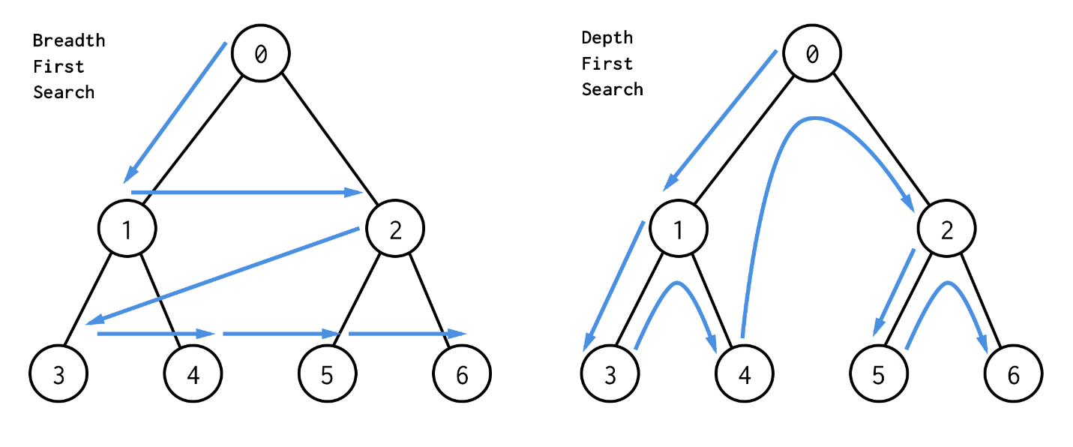

#### Coding Practice

* <https://leetcode.com/tag/depth-first-search/>
* <https://leetcode.com/tag/breadth-first-search/>

### Binary Search

In computer science, binary search is a search algorithm that finds the position of a target value within a **sorted** array. Binary search compares the target value to the middle element of the array; if they are unequal, the half in which the target cannot lie is eliminated and the search continues on the remaining half until it is successful. If the search ends with the remaining half being empty, the target is not in the array.

#### How it works

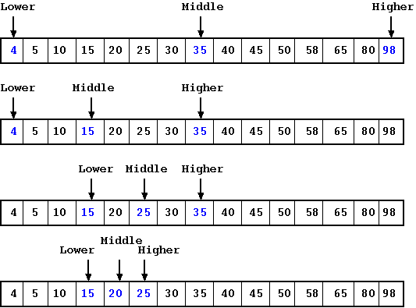

#### Code

def binarysearch(sequence, value):

lo, hi = 0, len(sequence) - 1

while lo <= hi:

mid = lo + (hi-lo) // 2

if sequence[mid] < value:

lo = mid + 1

elif value < sequence[mid]:

hi = mid - 1

else:

return mid

return None

#### Coding Practice

<https://leetcode.com/tag/binary-search/>

### Introduction to Dynamic programming

Definition

In computer science, mathematics, management science, economics and bioinformatics, dynamic programming (DP) is a method for solving a complex problem by **breaking it down** into a collection of simpler subproblems, **solving each of those subproblems just once**, and storing their solutions. The next time the same subproblem occurs, instead of recomputing its solution, one simply looks up the **previously computed solution**, thereby saving computation time at the expense of a (hopefully) modest expenditure in storage space. The technique of storing solutions to subproblems instead of recomputing them is called "**memoization**".

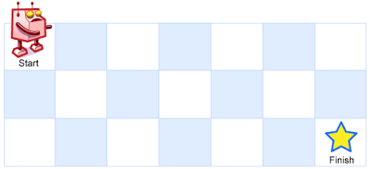

NOT EASY TAKE TIME TO UNDERSTAND!

# Week 4 - Flask

**Monday**

* Setup Flask Project
* Routing
* Jinja2 Templates & How They Work
* **Exercise**: Commit Flask project to GitHub

**Tuesday**

* Flask Bootstrap
* Organizing file structure
* Mixins
* Decorators
* **Workshop**: Control flow with Jinja2

**Wednesday**

* Flask Forms (WTForms)
* MVC and web app design
* Flask Database Setup with SQLite
* **Workshop**:
  + Flask app using web form for login page
  + Web application refactor

**Thursday**

* Registration & Login
  + User Authentication
  + Password Hashing
* Database Migration
* User Query
* **Exercise**:
* **Workshop**: Login/Registration Page Working with SQLite Database

**Friday**

* **Interviews:** 10 minutes per person
* **Project:** Convert NZA Law website to a Flask Application
* **Weekend Challenge**:
  + Finish Converting NZA Law website to a Flask Application (commit)

## Extra Reading

### 

### What is Flask

Flask is a **microframework** for Python based on Werkzeug, Jinja2.

* **Werkzeug** is a utility tools for the Web Server Gateway Interface (WSGI) is a specification for simple and universal interface between web servers and web applications or frameworks for the Python programming language.
* **Jinja2** is a modern and designer-friendly templating language for Python

### Routing

In Flask The route() decorator is used to bind a function to a URL.

@app.route('/')

def index():

return 'Index Page'

@app.route('/hello')

def hello():

return 'Hello, World'

### Flask Cheat Sheet

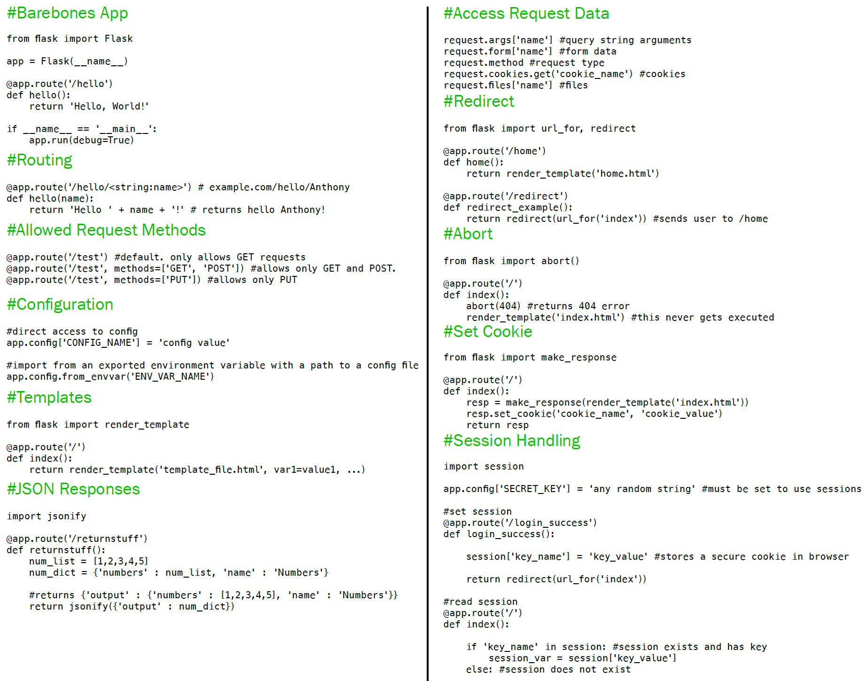

### Mixins in Python

Python supports a simple type of **multiple inheritance** which allows the creation of Mixins.

Mixins are a sort of class that is used to "mix in" extra properties and methods into a class. This allows you to create classes in a compositional style.

Please Note: The correct way to use Mixins is like in the reverse order because the priority of how methods are resolved is from left to right.

class Mixin1(object):

def test(self):

print "Mixin1"

class Mixin2(object):

def test(self):

print "Mixin2"

class MyClass(Mixin2, Mixin1, BaseClass):

pass

### Decorator in Python

Decorators are **functions** which modify the functionality of another **function**. They help to make our code shorter and more **Pythonic**.

### Example

# define the first decorator

def a_new_decorator(a_func):

def wrapTheFunction():

print("I am doing some boring work before executing a_func()")

a_func()

print("I am doing some boring work after executing a_func()")

return wrapTheFunction

def a_function():

print("I am the function which needs some decoration")

@a_new_decorator

def a_function_2():

print("I am the function which needs some decoration")

Call it

a_function = a_new_decorator(a_function)

a_function()

Same as above

a_function_2()

### Setup Flask Project

### Using Visual Studio Code

* Create a new project using Visual Studio Code.
* Check the project settings and make sure the project python interpreter is setup as well.
* Create the basic Flask application

### Git

Git ignores files.

Ignore some files, which are not necessary to put in repo.

GitHub and Remote

Create a GitHub project

Adding remote repo, usually we call it Origin, but we can give any name.

Using Branch

Branch the work and git keep all branch information In the same project folder

### Run Flask application

1. Using flask commands

FLASK_APP=hello.py

or for windows

set FLASK_APP=hello.py

1. Using directly call python file and in code execute app.run()

### What is Flask

Flask is a **microframework** for Python based on Werkzeug, Jinja2.

* **Werkzeug** is a utility tools for the Web Server Gateway Interface (WSGI) is a specification for simple and universal interface between web servers and web applications or frameworks for the Python programming language.
* **Jinja2** is a modern and designer-friendly templating language for Python

### Micro framework and Extensions

* Micro framework does less for you and leaves more freedom on how you write and organize your code
* Extensions are a very important part of the Flask ecosystem. They provide solutions to common problems

There are lots of flask extensions we can use, for example

* flask-wtf
* flask-sqlalchemy
* flask-migrate
* flask-login

### Setting up Flask for the first time

* Create a brand new, empty directory
* In your terminal type: python3 -m venv venv
* Activate your new virtual environment (venv): pip install flask

### Install a package

$ pip install <package-name>

### Very Basic Flask App

from flask import Flask

app = Flask(__name__)

@app.route("/")

def hello():

return "Hello World!"

### Routing

Decorator In Flask The @app.route() **decorator** is used to bind a function to a URL.

@app.route('/')

@app.route('/hello')

Http methods

@app.route('/login', methods=['GET', 'POST'])

### Redirect and Generating Links

from flask import redirect, flash, url_for

…

redirect(url_for(**'login'**))

### Jinja

In Flask, templates are written as **separate** files, stored in a **templates folder** that is **inside the application package**.

#### Render template

The operation that converts a template into a complete **HTML** page is called rendering. To render the template I had to import a function that comes with the Flask framework called render_template(). This function takes a template filename and a variable list of template arguments and returns the same template, but with all the placeholders in it replaced with actual values.

#### [Jinja2](http://jinja.pocoo.org/)

Jinja2 is a modern and designer-friendly templating language for Python.

* The render_template() function invokes the [Jinja2](http://jinja.pocoo.org/) template engine that comes bundled with the Flask framework.
* Jinja2 substitutes {{ ... }} blocks with the corresponding values, given by the arguments provided in the render_template() call.

#### Control Flow

Repeating

{% for post in posts %}  
<**div**>  
 <**H1**>{{ post.title }}</**H1**>  
 {{ post.body }}  
</**div**>  
{% endfor %}

Condition

{% if title %}  
<**title**>{{ title }} - !</**title**>  
{% else %}  
<**title**>Welcome!</**title**>  
{% endif %}

#### Template Inheritance

* Create a base.html that contains the that are common layouts such as navigation bar, header and footer to all other templates.
* In the Base template set placeholder

{% block content %}{% endblock %}

* Other templates extend base.html

{% extends "base.html" %}

## 

### Flask Bootstrap

### Install flask_bootstrap



### Importing to App

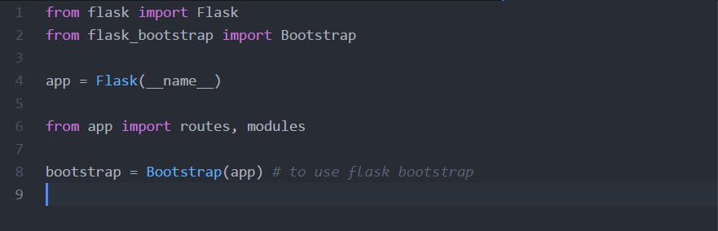

### Using flask_bootstrap

* Flask-Bootstrap allows you to incorporate Bootstrap, without the hassle of importing it everywhere
* Extending from the layout allows for ease of use
* One time editing
* Basic documentation:
  + <https://pythonhosted.org/Flask-Bootstrap/basic-usage.html>
* Key block statements:
  + Block Title
  + Block Navbar
  + Block Content
  + Block App_Content

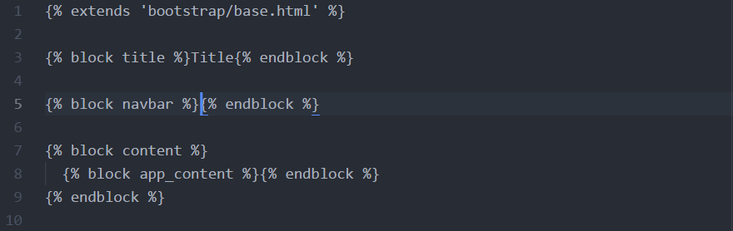

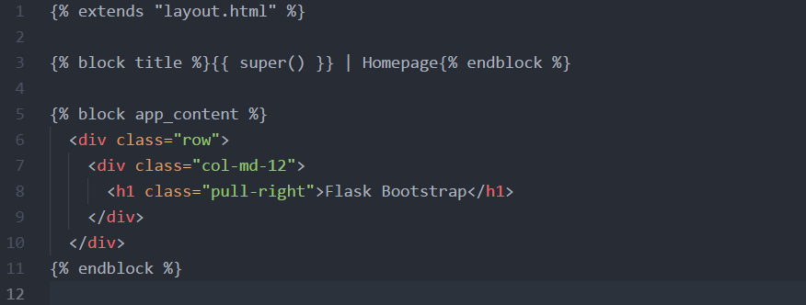

Flask bootstrap incorporates the same principles as Bootstrap; however, it allows you to use the “extends” functionality to keep your project clean and easily editable.

## 

### Flask WTF

### Install the extension

install flask-wtf

### app.config and SECRET_KEY

app.config['SECRET_KEY'] = 'you-never-know'

* app.config is **like** a dictionary. We can set and get the value by key.
* **SECRET_KEY** configuration variable is an important part in Flask applications. Flask and some of its extensions use the value of the secret key as a cryptographic key, useful to generate signatures or tokens. The Flask-WTF extension uses it to protect web forms against a nasty attack called Cross-Site Request Forgery or CSRF.

### Using flask-wtf

* Create a class named LoginForm extend from (FlaskForm)
* In route create a **form object** and pass to it the template for rendering.
* Using **form object** in the Jinja2 template

### Security and Hidden tag

**CSRF** or XSRF (Cross-site request forgery), also known as one-click attack or session riding (pronounced sea-surf). It is a type of malicious exploit of a website where unauthorized commands are transmitted from a user that the web application trusts.

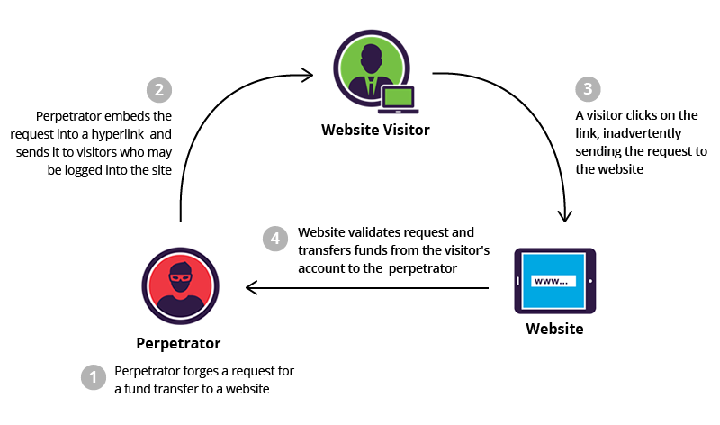

form.hidden_tag() generates a hidden field that includes a token used to protect the form against CSRF attacks according to **SECRET_KEY**.

### Receiving Form Data

Get or Post?

* Rendering the page is Get
* Submit form is post

Using form.validate_on_submit()

* Checking
* Distinguish http methods

### MVC and web app design

#### MVC

The Model-View-Controller (MVC) is not a technology, but a concept in software design/engineering. The MVC consists of three components, the Model, the View and the Controller

From https://helloacm.com/model-view-controller-explained-in-c/

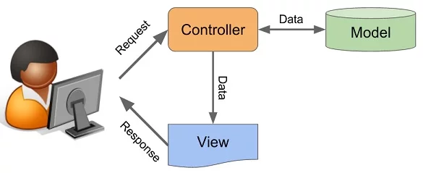

##### THE MODEL

The Model is directly responsive for handling data

#### VIEW

The View component knows how to present the Data to the users.

#### CONTROLLER

The Controller can ask the Model to update its data. Also, the Controller can ask the View to change its presentation. Basically, it is a component that takes input from the user and sends commands to the View or Model.

### Refactoring project

* Arrange code and put file to different modules.
* Follow common designs.

### Flask Database

#### Database

* Storing data.
* Special designed application.

#### SQLAlchemy

Flask-SQLAlchemy, an extension that provides a Flask-friendly wrapper to the popular SQLAlchemy package, which is an Object Relational Mapper or **ORM**

To install Flask-SQLAlchemy, an extension

(venv) $ pip install flask-sqlalchemy

#### Flask-Migrate

Flask-Migrate is an extension that handles SQLAlchemy database migrations for Flask applications using Alembic. The database operations are provided as **command line** arguments for Flask-Script. To Install flask-migrate

(venv) $ pip install flask-migrate

#### Database Models

The data that will be stored in the database will be represented by a collection of **classes**, usually called database models.

#### Flask-SQLAlchemy Configuration

SQLALCHEMY_DATABASE_URI = 'sqlite:///' + os.path.join(basedir, 'app.db')

SQLALCHEMY_TRACK_MODIFICATIONS = False

and

db = SQLAlchemy(app)

migrate = Migrate(app, db)

#### CODE First Steps

1. # Create Database Models in python
2. flask db init
3. flask db migrate -m "users table"
4. flask db upgrade

### SQLite

SQLite is a relational database management system contained in a C programming library. It stores data in file system.

The database file is able to opened in GUI application. Such as <http://sqlitebrowser.org/>

### CODE first approach

Create database model in code first. Then generate the DDL SQL code using Migrate. Run update to create Database definitions.

After that, both database side and application side is able to run DML. Such as

insert into user values (3,'admin','admin@test.com','666666')

insert into post values(1, 'I love Python', 'this is a happy story', 'Python can do everything. However, it is very easy.',2)

insert into post values(2, 'I hate Python', 'this is a sad story', 'Python can do everything. However, it is very hard.',2)

### Flask-Login

#### Installation

(venv) $ pip install flask-login

#### Password Hashing

>>> from werkzeug.security import generate_password_hash

>>> hash = generate_password_hash('foobar')

>>> hash

'pbkdf2:sha256:50000$vT9fkZM8$04dfa35c6476acf7e788a1b5b3c35e217c78dc04539d295f011f01f18cd2175f'

#### Using ORM for query database

*# get the user from data base use code*user = User.query.filter_by(username=form.username.data).first()

*# get all post*

posts = Post.query.all()

#### UserMixin

Added four required items for User, just not repeating some code already done by others.

* is_authenticated: a property that is True if the user has valid credentials or False Otherwise.
* is_active: a property that is True if the user's account is active or False otherwise.
* is_anonymous: a property that is False for regular users, and True for a special, anonymous user.
* get_id()

# Week 5 - Database

**Monday**

* Spreadsheet vs Database
* Different types of databases: NoSQL, CSV, SQLite, JSON, etc.
* Concept of relational database. Introduce relational model PK, FK, CK…
* Install PostgreSQL (Make sure install the **sample database**) and introduce other tools.
* Statements: SELECT, WHERE, AS, GROUP BY and FROM
* **Exercise:** 
  + Draw PK and FK (in class)
  + Setup database environment
  + Working on the ‘sakila’ database!
* **Workshop:**
  + Familiarization with SELECT, WHERE, AS and FROM statements

**Tuesday**

* Subqueries
* DDL, DML, DCL, TCL
  + CREATE, ALTER, DELETE, UPDATE
* Constraints
* **Exercise:** 
  + SQL script exercise II – DDL

**Wednesday**

* JOINs
* SQL Tools
  + SQLite Viewer
  + DB Designer
* **Exercise:**
  + Class exercises

**Thursday**

* Database Design
* Normalization
* Advance topics
* **Exercise**:
  + SQL script exercise III – **sakila** table Q1-Q4
  + SQL script exercise IV – **sakila** table Q5-Q10

**Friday**

* **Interviews:** 10 minutes per person
* **Project:** Build Car Dealership Database and Answer Questions
* **Weekend Challenge**:
  + Convert NZA Law SQLite Database to PostgreSQL
  + **Extra**: Use Elephant SQL for Cloud Database

## Extra Reading

### Spreadsheet vs Database

* A **spreadsheet** is an application for tabulating data while a **database** is where data is stored so that it can be retrieved by users the amount of data that is usually stored in a database is **way more** than what is contained in a spreadsheet.
* A **spreadsheet** is edited directly by people while a **database** is accessed by applications that enter and modify data.
* A **spreadsheet** is usually used for presentations and paper works while **databases** are commonly used in cases where **a lot of** data needs to store.

### Top to Down

DBMS -> Schema -> Tables - > (Attribute, Record)

### Terminologies

**SQL** – Structured Query Language. SQL is a domain-specific language used in programming and designed for managing data held in a relational database management system (RDBMS).

**DBMS** - Database Management System

* Aggregate of data, software, hardware and users that helps an organization manage its operational data
* Provide efficient and reliable methods of data retrieval
* Involves monitoring, administration, and maintenance of the databases

**Model vs Schema**

* **Model - Database Model** is a type of data **model** that determines the logical and **conceptual** structure of a **database** and fundamentally determines in which manner data can be stored, organized and manipulated. The most popular example of a **database model** is the relational **model**, which uses a table-based format.
* **Schema -** is a collection of database objects (tables) associated with one database username.
  + The username is called the **schema** **owner**, or the owner of the related group.
  + A database may have one or multiple **schemas**.

**Database build block**

* **Entity** - Real world object such as a person, place, thing or an abstract object such as a course, a flight reservation etc.
* **Entity Set** is a collection of similar types of entities and is represented by a table
* **Attribute -** Thecolumn
* **Record -** Therow

### Install PostgreSQL and introduce other tools

### Install PGAdmin4

**Windows/Mac/Linux**

Use the **installer** to install **make sure install the sample database**: <https://www.enterprisedb.com/downloads/postgres-postgresql-downloads>

* Choose the most install the most recent version
* Choose your operating system
* When the executable file downloads, click on it to run it
* Choose your installation directory. Select a directory that’s easily accessible
* Uncheck Stack Builder
* Choose your data directory. The default is fine.
* Create a password. **SAVE THIS PASSWORD** and make it something simple, like ‘admin’

### Concept of relational database.

The key of Relational Database is Relationship.

#### Keys

#### PK - Primary key

#### FK - Foreign key

#### CK - Candidate key

#### UK – Unique key

#### Simple Key

#### Compound Key

#### More about Foreign key

* A primary key from another table.
* A link that connect two tables.
* A FK usually not unique in the table and cannot be a candidate key.
* To delete a record, the record must not be referenced via its foreign key by other entity.

### Cardinality

* 1:M – the foreign key is always on the M side
* 1:1
* M:M - using a join table

Example Student table and School Table

### SQL

**Structured Query Language**. SQL is a domain-specific language used in programming and designed for managing data held in a relational database management system (RDBMS).

* DDL (Data definition Language)
* DML (Data manipulation Language)
* DCL (Data Control Language)
* TCL (Transaction control language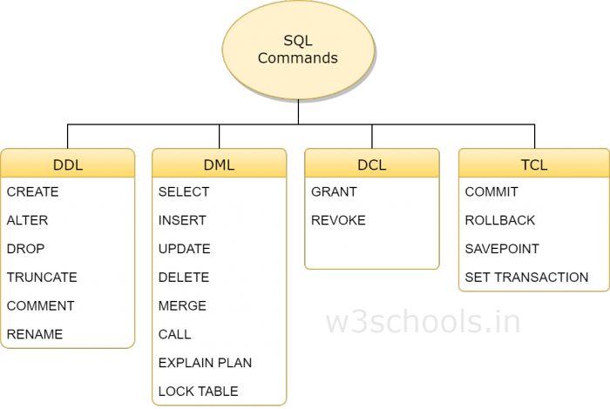)

(reference from w3schools.in)

#### DDL

DDL is short name of **Data Definition Language,** which deals with database schemas and descriptions, of how the data should reside in the database.

* **CREATE**– to create database and its objects like (**table**, index, views, stored procedure, function, and triggers)
* **ALTER TABLE** – alters the structure of the existing database
* **DROP TABLE** – delete objects from the database
* **TRUNCATE TABLE** – remove all records from a table, including all spaces allocated for the records are removed
* **COMMENT TABLE** – add comments to the data dictionary
* **RENAME TABLE** – rename an object

##### Type

In PostgreSQL there are three main data types: **text**, **number**, and **date**.

##### Constraints

NOT NULL - Ensures that a column cannot have a NULL value

UNIQUE - Ensures that all values in a column are different

PRIMARY KEY - A combination of a NOT NULL and UNIQUE. Uniquely identifies each row in a table

FOREIGN KEY - Uniquely identifies a row/record in another table

CHECK - Ensures that all values in a column satisfies a specific condition

DEFAULT - Sets a default value for a column when no value is specified

INDEX - Used to create and retrieve data from the database very quickly

#### DML

DML is short name of **Data Manipulation Language** which deals with data manipulation and includes most common SQL statements such SELECT, INSERT, UPDATE, DELETE etc, and it is used to store, modify, retrieve, delete and update data in a database.

* **SELECT** xxx **FROM** – retrieve data from a database
* **INSERT INTO table_name** VALUES **()** – insert data into a table
* **UPDATE … SET Where** – updates existing data within a table
* **DELETE FROM Where**– Delete all records from a database table
* MERGE – UPSERT operation (insert or update)
* CALL – call a PL/SQL or Java subprogram
* EXPLAIN PLAN – interpretation of the data access path
* LOCK TABLE – concurrency Control

#### DCL

DCL is short name of **Data Control Language** which includes commands such as GRANT and mostly concerned with rights, permissions and other controls of the database system.

* GRANT – allow users access privileges to database
* REVOKE – withdraw users access privileges given by using the GRANT command

#### TCL

TCL is short name of Transaction Control Language which deals with a transaction within a database.

* **COMMIT** – commits a Transaction
* **ROLLBACK** – rollback a transaction in case of any error occurs
* SAVEPOINT – to roll back the transaction making points within groups
* SET TRANSACTION – specify characteristics of the transaction

### Change default schema

* Use database_name

### SELECT statement and advanced query

#### The order of the select call (Very important!)

1. Select xx, **distinct** xxx **as** x, xx
2. from
3. join xxx on
4. where
5. group by
6. having
7. order by
8. limit xx offset xx

### Join

* Inner join - the default way to join
* Left join
* Right join
* Outer join
* Cross join - could result in some performance issue.

### Where

Give a condition and filter out the result. (In, like, %)

### Group by, Aggregation functions, and Having

Arrange identical data with aggregation function. Merge identical (group by) attribute to 1.

|  |  |  |
| --- | --- | --- |
| **Function Name** | **Meaning** | **Example** |
| SUM (column name) | Total of the values in a numeric column | SUM(SALARY) |
| AVG (column name) | Average of the values in a column | AVG(SALARY) |
| MAX (column name) | Largest value in a column | MAX(SALARY) |
| MIN (column name) | Smallest value in a column | MIN(SALARY) |
| COUNT (*) | Count of the number of rows selected | COUNT (*) |

Having, apply filter condition to aggregation functions. Unofficially say, Having is to Group by as Where is to Select.

### Order *By*

Sort the result. Order by sorts by ascending by default. **DESC** is used for descending sort.

### Limit and Offset

* Only for MySQL and PostgreSQL,
* T-SQL using top, pl-sql use where rownum <= n
* Return the 4th-7th record. Two ways and they work **equally**. Total return rows limited to 4, from index 3, since 0-based index, the first return record is from 4th.
  + Limit 3,4
  + Limit 4 offset 3

### Entity-Relationship (ER) Model

Entity Relationship Diagram. An entity relationship model, also called an entity-relationship (ER) diagram, is a graphical representation of entities (which will become your tables) and their relationships to each other. Database modeling is the process of creating a data model.

#### Diagram

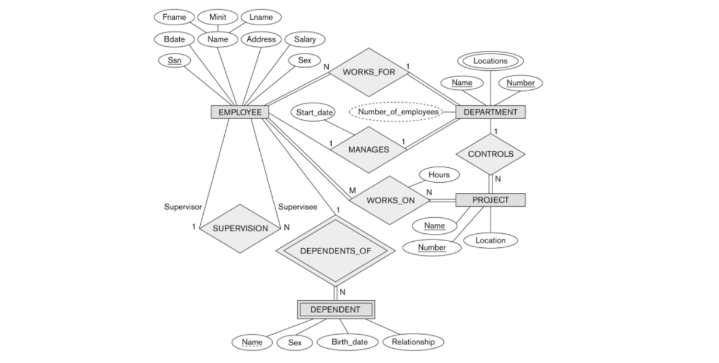

* Entity
  + Strong entities - exist independently from other entity types
  + Weak entities - depend on some other entity type
  + Associative entities - associate the instances of one or more entity types
* Relationship, Recursive Relationship
* Attribute, Primary Key, Composite Attribute, Multi-valued Attribute, Derived Attribute

#### Map

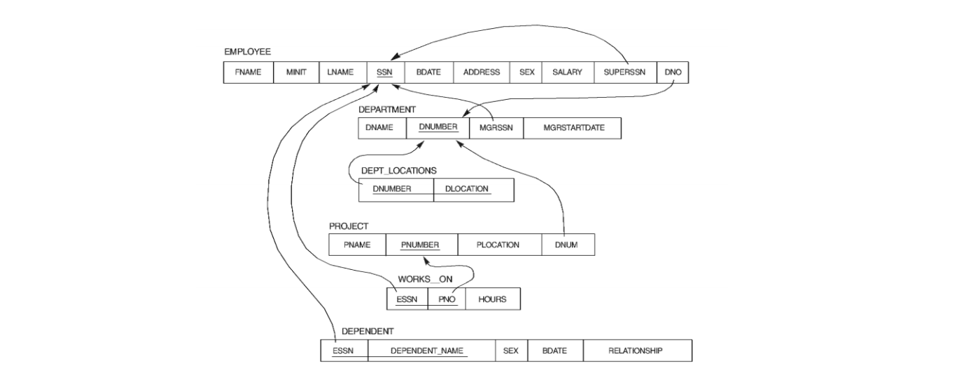

### Database Design

#### Data model Thinking

* What elements of the data will be stored
* How large each element can be?
* What kind of information each element can contain
* What elements may be left blank
* Which elements are constrained to a fixed range?
* Whether and how various tables are to be linked

Data model is connected to each entity together

* Documents the organization of the data
* Conceptual framework to specify database requirements
* Data Model are usually abstract
* Specified in a graphical model notation

#### ACID Properties

When a transaction processing system creates a transaction, it will ensure that the transaction will have certain characteristics. (https://msdn.microsoft.com/en-us/library/aa480356.aspx)

* **Atomicity** - The atomicity property identifies that the **transaction** is atomic.
* **Consistency** - A transaction enforces **consistency** in the system state by ensuring that at the end of any transaction the system is in a valid state.
* **Isolation** - When a transaction runs in **isolation**, it appears to be the only action that the system is carrying out at one time.
* **Durability** - A transaction is **durable** in that once it has been successfully completed, all of the changes it made to the system are permanent.

#### CAP Theorem

It is impossible for a **distributed computer system** to simultaneously provide all three of the following guarantees

* **Consistency** - Clients get the same view of data
* **Availability** - All requests will receive a response
* **Partition tolerance** - System continues to work despite message loss or partial failure

#### Normalization

* Improves relational table design to minimize data redundancy
* Involves increasing the number of database tables
* Degrees of normalization: – 1NF, 2NF, 3NF, BCNF, 4NF, 5NF

### Advance topics

#### The Join Table

Used To model many-to many relationships – Mapped by 2 independent 1: N unidirectional relations.

#### Indexing

Index is a data structure that improve the speed of data retrieval operations on its table. The cost is additional writes(computing time) and storage space to maintain the index.

* Data structure technique to efficiently retrieve records from the database
* Based on attributes on which the indexing has been done
* Each index is associated with **only one table**

#### Stored Procedures

In a database management system (DBMS), a stored procedure is a set of Structured Query Language (SQL) statements with an assigned name that's stored in the database in compiled form so that it can be shared by many programs.

* Create a stored procedure require ALTER permission.
* Stored procedures can have both input parameters and output parameters.

#### SQL Functions

* SQL functions are used to compute values. Functions cannot perform permanent changes.
* There are two kinds functions, built-in and user defined function(UDF).
* **Insert update statements are not allowed.**
* Must return a value.
* Only input parameters, no output parameters.

#### View

* View is a virtual table itself not store any data.
* View are for end user and cannot be used to manipulate data. It cannot perform modification to any table
* View do not accept any parameter. It is used as a table.
* A view can be created from another view.

#### Triggers

SQL trigger is a special type of stored procedure. It is special because it is not called directly like a stored procedure. The main difference between a trigger and a stored procedure is that a trigger is called automatically when a data modification event is made against a table whereas a stored procedure must be called explicitly.

#### Partitioning

Partitioning enables tables and indexes, or index organized tables to be subdivided into smaller manageable pieces and these each small piece is called a "partition".

##### Advantages of partitioning

* Smaller and more manageable pieces of data (Partitions )
* Reduced recovery time
* Failure impact is less
* import / export can be done at the " Partition Level".
* Faster access of data
* Partitions work independent of the other partitions.
* Very easy to use

### TCL - Transaction Control

* Allows statements to be grouped together into logical transactions
* COMMIT - save work done
* SAVEPOINT - identify a point in a transaction to which you can later roll back
* ROLLBACK - restore database to original since the last commit
* SET TRANSACTION - change transaction options like isolation level and what rollback segment to use

### NOSQL

* SQL = Traditional relational DBMS.
* NoSQL = Not using traditional relational DBMS, No Table

#### Type of NoSQL

* Key-Value Store
* Document Store
* JavaScript Object Notation (JSON)
* Extensible Markup Language (XML)
* Column Store
* Graph Databases

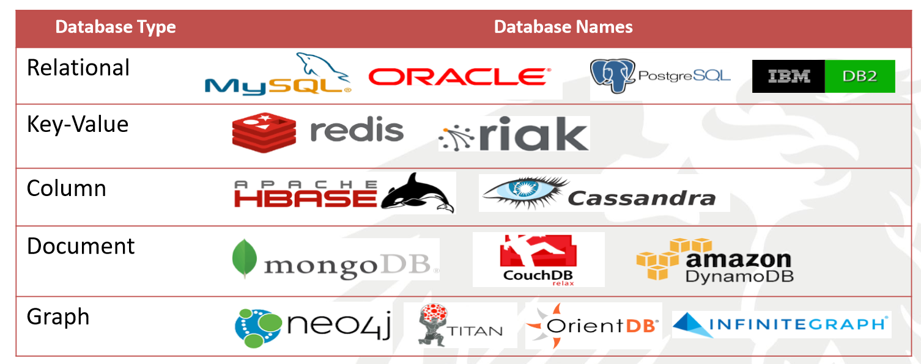

#### Facts

* Column database is widely used for BIG DATA
* **JSON** is widely used in NOSQL
* Graph database is usually used for social network graph
* mongoDB is still the most popular NoSQL in 2018 😊, which is a document-based database.
* Two NO SQLs went to a bar and immobility quit, Why? Because there are no tables.

### JSON

JSON is JavaScript Object Notation

* Data object is in name/value pairs by :
* Data object is separated by commas ,
* Curly braces hold objects {}
* Square brackets hold arrays []

#### JSON values

* A number (integer or floating point)
* A string (in double quotes)
* A Boolean (true or false)
* An array (in square brackets)
* An object (in curly braces)
* null

#### JSON Objects are written inside curly braces.

{"firstName":"John", "lastName":"Doe"}

#### JSON arrays are written inside square brackets

[ {"firstName":"John", "lastName":"Doe"}, {"firstName":"Anna", "lastName":"Smith"}, {"firstName":"Peter","lastName":"Jones"} ]

### MongoDB

* No Predefined Database.
* MongoDB transfers and stores data in BSON. Binary JSON.

#### Hierarchical Objects

* A MongoDB instance may have zero or more **databases.**
* A database may have zero or more **collections**.
* A collection may have zero or more **documents**.
* A document may have one or more **fields**.

#### List and switch database

* show dbs
* use a_database

#### CRUD operations

* **Create** – db.collection.insert( <document> ) – db.collection.save( <document> ) – db.collection.update( <query>, <update>, { upsert: true } )
* **Read** – db.collection.find( <query>, <projection> ) – db.collection.findOne( <query>, <projection> )
* **Update** – db.collection.update( <query>, <update>, <options> )
* **Delete** – db.collection.remove( <query>, <justOne> )

#### Installation

* To download and install MongoDB for Windows and Mac, follow this. [https://docs.mongodb.com/manual/administration/install-community/](https://docs.mongodb.com/manual/administration/install-community/%20%20)
* Get the community version installer

<https://www.mongodb.com/download-center?jmp=nav#community>

* https://robomongo.org Download the tool

##### Run MongoDB

* Run **mongod**
* Create the folder for store data

#### Import data

mongoimport --db dbname --collection restaurants --drop –file filenamewithpath

Example:

**mongoimport --db test1 --collection restaurants --file C:\primer-dataset.json.txt**

# Week 6 - JavaScript

**Monday**

* Frontend
* How to learn another programming language
* JavaScript Language I
  + Types
  + Variable Constant …
  + Operations
  + Control flow
  + Syntax
* **Exercise:** 
  + Codewars - 20 points on Javascript Exercises

**Tuesday**

* JavaScript Language II
  + Functions
  + Objects and Prototypes
  + Scoping & Function Closures
* DOM Structure
* **Exercise:** 
  + Codewars - 20 points on Javascript Exercises

**Wednesday**

* JavaScript and working with the Document Object Model (DOM)
* jQuery
* **Demo:** jQuery and AJAX
* **Exercise:** 
  + jQuery
  + Write an entire Index file with only div tags (no text)

**Thursday**

* JSON
* APIs
* REST
* Postman
* **Exercise:** 
  + Reading and writing to JSON file
  + Displaying [Animal JSON file](https://learnwebcode.github.io/json-example/animals-1.json)

**Friday**

* **Interviews:** 10 minutes per person
* **Project:** Build functional shopping cart with jQuery and JSON
* **Weekend Challenge**:
  + Finish shopping cart and test with Postman (commit)
  + Flickr API

## Extra Reading

### Frontend

### What is frontend

Scripts or contents running on the Client sides.

* Web: HTML, CSS, JavaScript

### Web app

* **HTML** - Components, texts, the skeleton
* **CSS** - Tell brewer how to display
* **JavaScript** – Manipulate, and control at the runtime (event based)

### Frameworks and Libraries

* jQuery
* Bootstrap for styles
* Angular
* React
* Charts related such as highchart, amcharts…
* ….

### How to learn another programming Language

* Control flow and syntax
* Data types
* How to do functional programming
* How to do OO
* Languages special features
* AND Practices !!

### JavaScript Language

JavaScript is **notorious** for being the world's most misunderstood programming language.

* Often derided as being a toy, but powerful
* Easy to use, but hard to master
* Widely used
* Not java at all

JavaScript is great! JavaScript is a mess!

#### Overview

JavaScript is a multi-paradigm, **dynamic** language with **types** and **operators**, standard **built-in objects**, and **methods**. Its syntax is based on the *Java* and *C languages*. JavaScript supports object-oriented programming with object **prototypes**, instead of classes. JavaScript also supports **functional programming** — functions are objects, giving functions the capacity to hold executable code and be passed around like any other object.

#### Types

* Number
* String
* Boolean
* Symbol (new in ES2015)
* Object
  + Function
  + Array
  + Date
  + RegExp
* null
* undefined

#### Variables

New variables in JavaScript are declared using one of three keywords:

* const - declare variables whose values are never intended to change.
* let - declare block-level variables
* var – function scope

For traditional JavaScript var, blocks do not have scope; only functions have a scope.

#### Operators

JavaScript numeric operators are +, -, *, / and %. Values are assigned using =, and there are also **compound assignment** statements such as += and -=.

* != and !==
* == and ===

#### Control structures

* 3 ways, Line by Line, Branch, Repeating

##### Line by Line

From up to down.

##### Branch

if else

var name = 'kittens';

if (name == 'puppies') {

name += ' woof';

} else if (name == 'kittens') {

name += ' meow';

} else {

name += '!';

}

name == 'kittens meow';

Ternary operator for conditional expressions

var allowed = (age > 18) ? 'yes' : 'no';

#### Repeating

While loop

while (…) {

// an infinite loop!

}

For Loop

for (var i = 0; i < 5; i++) {

// i will be 0,1,2,3,4

}

For in Loop (object)

for (let property in object) {

// do something with object property

}

For of loop (array)

for (let value of array) {

// do something with value

}

### Number

Numbers in JavaScript are "double-precision 64-bit format IEEE 754 values", according to the spec. This has some interesting consequences. There's **no** **integer** in JavaScript.

0.1 + 0.2 == 0.30000000000000004;

Math.sin(3.5); //using Math

var circumference = 2 * Math.PI * r;

parseInt('123', 10); // 123 using parse

### String

Strings in JavaScript are sequences of [Unicode(**UTC16**) characters](https://developer.mozilla.org/en-US/docs/Web/JavaScript/Guide/Values,_variables,_and_literals#Unicode).

'hello'.length; // 5

'hello'.**charAt**(0); // "h"

'hello, world'.**replace**('hello', 'goodbye'); // "goodbye, world"

'hello'.**toUpperCase**(); // "HELLO"

### Array

Arrays in JavaScript are actually **a special type of object**. They work very much like regular objects (numerical properties can naturally be accessed only using [] syntax) but they have one magic property called **'length'**. This is always one more than the highest index in the array.

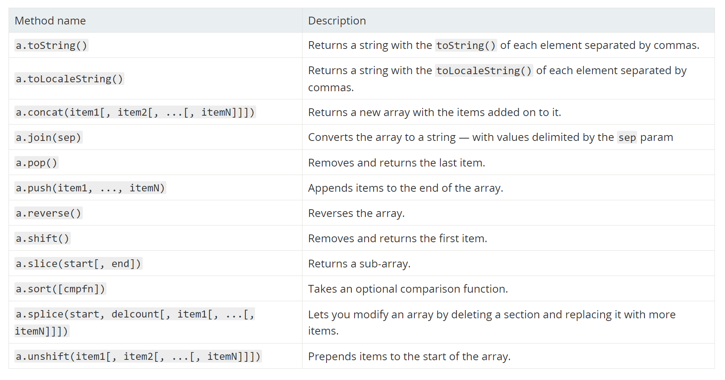

### Object

JavaScript objects can be thought of as simple collections of name-value pairs it is Dictionaries in Python.

var obj = {

name: 'Carrot',

_for: 'Max', // 'for' is a reserved word, use '_for' instead.

details: {

color: 'orange',

size: 12

}

};

There are **two basic ways** to create an empty object:

var obj = new Object();

var other_obj = {};

Creates an object **prototype**, Person and an instance, using function

function Person(first, last, age) {

this.first = first;

this.last = last;

this.age = age;

this.fullName = function() {

return this.first + ' ' + this.last;

};

this.fullNameReversed = function() {

return this.last + ', ' + this.first;

};

}

var you = new Person('You', 24); // Define an object

//dot notation

you.first = 'Senma';

var name = you.first;

// bracket notation

you['first'] = 'Yuri';

var name = you['first'];

### 

### Function

* A JavaScript function can take 0 or more named parameters.
* The function body can contain as many statements as you like and can declare its own variables which are local to that function.
* There is **no method overloading** concept in JavaScript. This is different from Python, Java, or C++
* The return statement can be used to return a value at any time, terminating the function. If no return statement is used (or an empty return with no value), JavaScript returns undefined.
* A function could be named function or anonymous function.

var s = function add(a,b){

return a+b

};

console.log(s(3,4))

let avg = function() {

var sum = 0;

for (var i = 0, j = arguments.length; i < j; i++) {

sum += arguments[i];

}

return sum / arguments.length;

};

console.log(avg(1,2,3,4))

If the function keyword appears first in the statement and is followed by a function name, the function is being created by a function declaration:

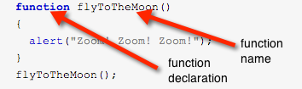

If the function keyword appears anywhere else, it is probably being used as a function operator  
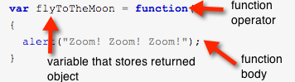

When the function operator is called, it creates a new function object and returns it.

### Closure

* Closure is powerful abstractions that JavaScript **has to** offer.
* A closure is the combination of a function and the scope object in which it was created. Closures let you save state — as such, they can often be used in place of objects.

### DOM

The **document object model** (DOM) is a **programming interface** for **HTML** and **XML** documents. It represents the page so that programs can **change** the document **structure**, content, and style. The DOM represents the **document** as **nodes** and **objects**. That way, **programming languages** can **connect** to the page.

In other word, DOM is an object-oriented representation of the web page, which can be modified with a scripting language such as JavaScript.

#### window

The **window** object represents a window containing a DOM document

* The document property points to the DOM document loaded in that window.
* A window for a given document can be obtained using the document.defaultView property.

#### document

A Web page is a **document**.

The **document** represents any web page loaded in the browser and serves as an entry point into the web page's content, which is the DOM tree. The DOM tree includes elements such as <body> and <table>, among many others. It provides functionality globally to the document, like how to obtain the page's URL and create new elements in the document.

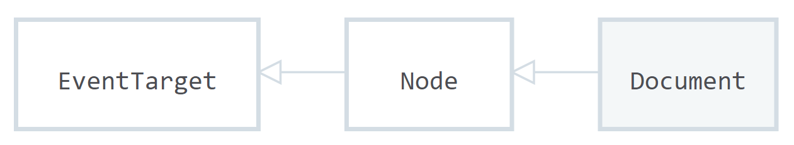

The Document interface describes the **common properties** and **methods** for any kind of document. Depending on the document's type (e.g. HTML, XML, SVG, …), a larger API is available:

* HTML documents, served with the "text/html" content type, also implement the HTMLDocument interface,
* XML and SVG documents implement the XMLDocument interface.

#### element and list of elements (nodeList)

* Every **element** is in the **document,** and **element** is part of the document object model.
* Every **element** can be accessed and manipulated using the DOM and a scripting language like JavaScript.

#### Programming language and DOM

* The DOM is not a programming language.
* Python also can used to manipulate the DOM.

The DOM was designed to be **independent** of any particular programming language, making the structural representation of the document available from a single, consistent API. Implementations of the DOM can be built for any language, such as Python:

# **Python** DOM example

import xml.dom.minidom as m

doc = m.parse("C:\\Projects\\Py\\chap1.xml");

doc.nodeName # DOM property of document object;

p_list = doc.**getElementsByTagName**("para");

### Summary

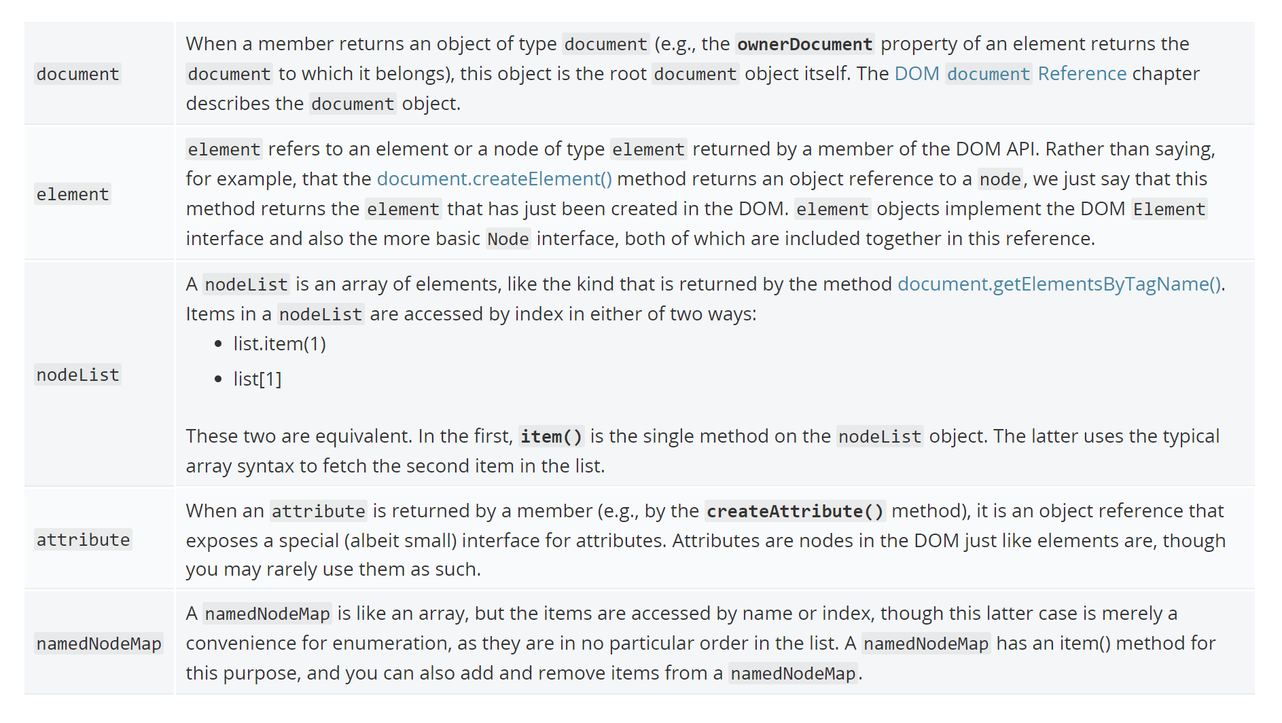

#### List of common APIs in web and XML page scripting using the DOM

* document.getElementById(id)
* document.getElementsByTagName(name)
* document.createElement(name)
* parentNode.appendChild(node)
* element.innerHTML
* element.style.left
* element.setAttribute()
* element.getAttribute()
* element.addEventListener()
* window.content
* window.onload
* window.dump()
* window.scrollTo()

#### In Class Experiment

* > window
* > document
* > window.document
* > document.defaultView
* > document.getElementById('xxxid').getAttribute('xxxid')
* > document.getElementById('xxxid').setAttribute('moAttribute', 'whatever')
* > document.getElementById('xxxid'). innerHTML

### DOM and JavaScript

Frontend app written in **JavaScript**. JavaScript uses the **DOM** to access the **document** and its **elements**.

* Every **element** is in the **document,** and **element** is part of the document object model.
* Every **element** can be accessed and manipulated using the DOM and a scripting language like JavaScript.

#### JavaScript in HTML – 3 approaches

#### In tag

<body onload="window.alert('Welcome to my home page!');">

#### Script block

<html>

<head>

<script>

// run this function when the document is loaded

window.onload = function() {

// create a couple of elements in an otherwise empty HTML page

var heading = document.createElement("h1");

var heading_text = document.createTextNode("Big Head!");

heading.appendChild(heading_text);

document.body.appendChild(heading);

}

</script>

</head>

<body>

</body>

</html>

#### Script reference

<script src="https://ajax.googleapis.com/ajax/libs/jquery/3.3.1/jquery.min.js">

</script>

### Access DOM in JavaScript

JavaScript access DOM by event by event such as onload, onBlur, onChange, onClick, onFocus, onSelect, onSubmit

### The equation

API = DOM + JS (scripting language)

### jQuery

jQuery is a **fast**, **small**, and feature-rich JavaScript library. It makes things like HTML document **traversal and manipulation**, **event handling**, **animation**, and **Ajax**.

#### Importing

Using CDN or Local

<script src="https://ajax.googleapis.com/ajax/libs/jquery/3.3.1/jquery.min.js"></script>

#### When to Manipulate DOM?

* You can start DOM manipulation as soon as the DOM has been constructed.
* However, usually, the best practices are when the DOM fully loaded.
* jQuery makes it easy to attach an event handler for the DOM readiness event.

$(document).ready(function(){

$("#p1").text("Hello World");

});

#### jQuery Core Function

* jQuery("#p1"); //Full name of the core function
* $("#p1"); //Shortcut name

#### jQuery Selectors

The concept of selector was borrowed from CSS. For most case just follow the rule of CSS

* ID is specified after ‘#’
* Class name is supplied after ‘.’
* Element by matching an attribute value

$("p").text("Hello World");

<body>

    <p id="p1"></p>

    <p id="p2"></p>

</body>

$(function(){

    $(".c1").text("You have class c1");

});

<p class="c1">Hello World</p>

<p class="c2">Hello Moon</p>

$("p[important=true]").text("This is an important paragraph.");

<p important="true"></p>

<p id="p2"></p>

#### Auto Start Func

$(function(){

$("#div1").text("Add Test by jQuery auto start func");

});

#### DOM Traversal and Manipulation

Get the <button> element with the class 'continue' and change its HTML to 'Next Step...'

$( "button.continue" ).html( "Next Step..." )

#### Event Handler Registration

jQuery makes it easy to register an event handler in a browser neutral way. Events are registered by calling the appropriate method of the jQuery object.

$("p").click(

function() {

alert($(this).text());

}

);

$("tr").hover(

function() {

$(this).css("background-color", "yellow");

},

function() {

$(this).css("background-color", "white");

}

);

### AJAX

Call a local script on the server/api/getWeather with the query parameter zipcode=97201 and replace the element #weather-temp's html with the returned text

$.ajax({

url: "/api/getWeather",

data: {

zipcode: 97201

},

success: **function**( result ) {

$( "#weather-temp" ).html(result + "degrees" );

}

});

$.getJSON(url, handlefunc);

### Intro to RESTful

#### Tradition Dynamic page and MVC model are dead.

* Page generated from the server side every time.
  + Server side keep the session of the web app.
  + Client tell what server what to do for the next step.
* Issues
  + Backend logic and frontend logic coupled. Hard to implementation and maintains.
  + Cannot take advantage latest frontend technology; not mobile friendly.
  + Backend cannot be distributed easily, not suitable for large scale application.
* MVC is a good design pattern. However, the good practice in on client device but not cross server and client.

#### 6 rules of REST system:

1. **Client-Server:** There should be a separation between the server that offers a service, and the client that consumes it.
2. **Stateless**: Each request from a client must contain all the information required by the server to carry out the request. In other words, the server cannot store information provided by the client in one request and use it in another request.
3. **Cacheable**: The server must indicate to the client if requests can be cached or not.
4. **Layered System**: Communication between a client and a server should be standardized in such a way that allows intermediaries to respond to requests instead of the end server, without the client having to do anything different.
5. **Uniform Interface**: The method of communication between a client and a server must be uniform.
6. **Code on demand**: Servers can provide executable code or scripts for clients to execute in their context. This constraint is the only one that is optional.

#### RESTful web service

The REST architecture was originally designed to fit the HTTP protocol. The concept of RESTful web services is the notion of resources. Resources are represented by URIs. The clients send requests to these URIs using the methods defined by the HTTP protocol, and possibly as a result of that the state of the affected resource changes. The HTTP request methods are typically designed to affect a given resource in standard ways:

|  |  |  |
| --- | --- | --- |
| HTTP Method | Action | Examples |
| GET | Obtain information about a resource | http://example.com/api/orders (retrieve order list) |
| GET | Obtain information about a resource | http://example.com/api/orders/123 (retrieve order #123) |
| POST | Create a new resource | http://example.com/api/orders (create a new order, from data provided with the request) |
| PUT | Update a resource | http://example.com/api/orders/123 (update order #123, from data provided with the request) |
| DELETE | Delete a resource | http://example.com/api/orders/123 (delete order #123) |

#### Data format

The REST design does not require a specific format for the data provided with the requests. In general data is provided in the request body as a JSON blob, or sometimes as arguments in the query string portion of the URL.

### JSON

JSON stands for Javascript Object Notation. It is used for storing and exchanging data either on your file system or from a separate resource. Over the last decade JSON has taken over XML as the primary means of exchanging data.

#### Format

* The format looks similar to that of Javascript Objects; however, it is slightly different in respect to how it is stored.
* Since the JSON format is text only, it can easily be sent to and from a server, and used as a data format by any programming language.

[

{

name: “John”,

age: 37

},

{

name: “Jade”,

age: 22

}

]

#### Working with JSON Files

JSON files are used strictly for storing and exchanging information. All data within them is written as Javascript Object Notation Syntax. A useable JSON file is shown below.

* *Keep in mind that all keys in the object syntax must be in quotes, whereas in normal Javascript Object syntax they do not.*
* A great validation tool is [JSON Lint](https://jsonlint.com/)

// people.json

{

“people”: [

{

“name”:”Brad”,

“age”: 35

},

{

“name”:”John”,

“age”: 24

},

]

}

There are two main methods when working with JSON files:

1. JSON.parse()
   1. When retrieving information parse is used to convert the data into a javascript object, which allows for easy compatibility
2. JSON.stringify()
   1. When sending or storing information you can convert a Javascript object into JSON by using the stringify method

// stringify data

var myObj = { “name”:”John”, “age”:37 };

var myJSON = JSON.stringify(myObj);

// parse data

var text = JSON.parse(‘{ “name”:”John”, “age”:37 }’);

##### GET/PUT Information

To request data from a JSON API you follow these steps:

1. Create new XMLHttpRequest variable
2. Open the request with the URL
3. Create a callback function
4. Parse the responseText
5. Send the response back to the HTML file

// request data

var ourRequest = new XMLHttpRequest();

ourRequest.open(‘GET’, ‘<https://address.goes.here>’);

ourRequest.onload = function() {

var myData = JSON.parse(ourRequest.responseText);

};

ourRequest.send(); // sends to html template

#### Creating a JSON API in Flask

One great benefit of working with Flask is that it allows for ease of use when working with JSON files. Whether you’re trying to request data or host data, creating a JSON API is simple and available within a couple lines of code, following the steps below:

1. Create a route API and define methods
2. Either pull data from a locally stored JSON file or use a Python Dict. Object
3. Return a ‘jsonified’ object

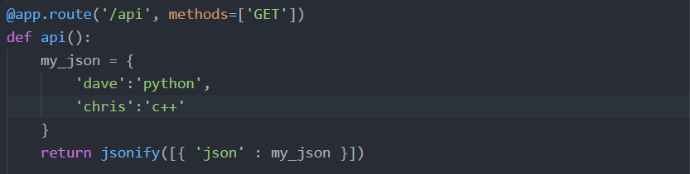

### Postman

Postman is commonly used as an API testing tool. Testing API endpoints is crucial in overall testing and debugging.

#### Installation

Postman can run in either the browser, or in the standalone app:

* Extension:
  + <https://chrome.google.com/webstore/detail/postman/fhbjgbiflinjbdggehcddcbncdddomop?hl=en>
* Standalone App:
  + <https://www.getpostman.com/apps>

Testing API endpoints:

**GET**

From the method dropdown list, select GET. Where it says ‘Enter Request URL’, type in the URL of the endpoint you’d like to test. For example: If you’ve made a store and you want to have all of your products show up in one page, this endpoint would return to you a JSON object of all of the products as well as their properties.

* <http://thisismytestwebsite.com/products> - shows all products
* [http://http://thisismytestwebsite.com/product/1](http://http//thisismytestwebsite.com/product/1) - shows a product which belongs to an id

**POST**

The POST method is responsible for sending data to your server. The data that’s being sent to the server is referred as a payload.

* [http://thisismytestwebsite.com/product](http://thisismytestwebsite.com/products) - Creates new product with the properties you’ve given the product.

**PUT**

Technically, the PUT method has two functions. It checks to see if an object already exists and if it doesn’t, it saves the data onto the server. The second thing it does is check whether it exists or not and if it does, it merely updates the information that already resides on that object.

* <http://thisismytestwebsite.com/product/1> - Updates product information

**DELETE**

One of the simpler server methods is the DELETE method. It simply does what it says; deletes already existing data from the server.

* http://thisismytestwebsite.com/products/1 - Deletes the product from server

# Week 7 - JS Framework (React)

**Monday**

* Install NodeJS and NPM (Node Package Manager)
* Install and setup basic React application
  + Difference between basic and normal setup
* ES6 Syntax
* **Exercise**:
  + Create Gem Store Application (commit)

**Tuesday**

* Component Life Cycle
* State Management
* **Workshop**:
  + Gem Store Shopping Cart functionality with Javascript (commit)
* **Extra:**
  + State Management w/ Redux (extra reading)

**Wednesday**

* Ergast API
* Firebase
* **Exercise**:
  + F1 Racer Application
* **Workshop**:
  + Gem Store Shopping Cart functionality w/Firebase (commit)

**Thursday**

* Payment Systems
  + Braintree
  + Stripe
* **Exercise**:
  + Add Payment System to Gem Store (commit)

**Friday**

* **Interviews:** 10 minutes per person
* **Exercise**:
  + Build shoe store application (commit)
* **Weekend Challenge**:
  + Finish shoe store application (commit)

## 

## Extra Reading

## 

### React

React is a declarative, efficient, and flexible **JavaScript library** for building user interfaces.

React is the V in MVC

#### Foundations to master React

* HTML CSS
* JavaScript (ES6 syntax)
* Npm

#### React version using in class

v16

#### React official site

<https://reactjs.org>

#### Usage and Compare another framework

* Big company use it such as Apple, Airbnb, Facebook, PayPal, redfin…

<https://medium.com/@coderacademy/32-sites-built-with-reactjs-172e3a4bed81>

* Why React is better than Angular

<https://medium.com/@chriscordle/why-angular-2-4-is-too-little-too-late-ea86d7fa0bae>

* But jQuery, you still need to know it well

#### Development Setup

* Node and NPM
* create-react-app <https://github.com/facebook/create-react-app>
* Chrome extension -> React developer tool
* IDE **Visual Studio Code**

#### Installation create-react-app

* For Windows > npm install -g create-react-app
* For Mac > sudo npm install -g create-react-app

#### Steps

npx create-react-app my-app2

cd my-app2

npm start

#### The smallest React example

ReactDOM.render(

<h1>Hello, world!</h1>,

document.getElementById('root')

);

### React Component

* React.Component is an abstract base class
* Subclass it and define **at least a render() method**

#### The Component Lifecycle

* Each component has several “lifecycle methods” that you can override to run code at particular times in the process.
* Methods prefixed with will are called right before something happens, and methods prefixed with did are called right after something happens.

##### Mounting

These methods are called when an instance of a component is being created and inserted into the DOM:

1. [constructor()](https://reactjs.org/docs/react-component.html#constructor)
2. [componentWillMount()](https://reactjs.org/docs/react-component.html#componentwillmount)
3. [render()](https://reactjs.org/docs/react-component.html#render)
4. [componentDidMount()](https://reactjs.org/docs/react-component.html#componentdidmount)

##### Updating

An update can be caused by changes to props or state. These methods are called when a component is being re-rendered:

1. [componentWillReceiveProps()](https://reactjs.org/docs/react-component.html#componentwillreceiveprops)
2. [shouldComponentUpdate()](https://reactjs.org/docs/react-component.html#shouldcomponentupdate)
3. [componentWillUpdate()](https://reactjs.org/docs/react-component.html#componentwillupdate)
4. [render()](https://reactjs.org/docs/react-component.html#render)
5. [componentDidUpdate()](https://reactjs.org/docs/react-component.html#componentdidupdate)

##### Unmounting

This method is called when a component is being removed from the DOM:

1. [componentWillUnmount()](https://reactjs.org/docs/react-component.html#componentwillunmount)

##### Error Handling

This method is called when there is an error during rendering, in a lifecycle method, or in the constructor of any child component.

1. [componentDidCatch()](https://reactjs.org/docs/react-component.html#componentdidcatch)

### Firebase

Firebase is a mobile and web application development platform. It’s a BaaS (Backend-as-a-Service) developed by Firebase and acquired by Google. Currently it is used as a Cloud Database platform for web applications using JSON file formatting for storage.

#### Requirements

Firebase requires that you have Node installed before using the platform or that you have a web application already programmed using Javascript functionality.

#### Use Cases

* Mobile applications
* Analytics
* Hosting
* Databases

#### Adding Firebase to Your Application

You can follow the beginning steps here: [Firebase Setup Steps](https://firebase.google.com/docs/web/setup)

1. Add Firebase to app

// add firebase to app

<script

src=”https://www.gstatic.com/firebasejs/5.0.3/firebase.js”>

</script>

1. [Create a new project](https://console.firebase.google.com/u/0/project/_/database/data)
2. Add database to app

// add database to app

<script

src=”https://www.gstatic.com/firebasejs/4.12.0/firebase-database.jss”>

</script>

1. Add database configuration to app

<script>

// initialise database

var config = {

apiKey: “<API_KEY>”,

authDomain: “<PROJECT_ID>.firebaseapp.com”,

databaseURL: “https://<DATABASE_NAME>.firebaseio.com”,

projectId: “<PROJECT_ID>”,

storageBucket: “<BUCKET>.appspot.com”,

messagingSenderId: “<SENDER_ID>”

};

firebase.initializeApp(config);

</script>

#### Realtime Database

The Firebase Realtime Database is a cloud-hosted database. Data is stored as JSON and synchronized in realtime to every connected client. When you build cross-platform apps with our Android, iOS, and JavaScript SDKs, all of your clients share one Realtime Database instance and automatically receive updates with the newest data.

##### Storing Database

Using the realtime database, you can see the cloud database update whenever a change occurs. Follow these steps in order to store to Firebase:

1. Get a database reference

// get reference to firebase database

var database = firebase.database()

1. Set values on database

// write data to firebase database

function writeData(items) {

firebase.database().ref(‘my_items’).set({

‘items’: items

});

}

##### Retrieving Database

With the realtime database you can read/write and even continually update when an event occurs. To read from the database, it’s as simple as a .ref() function with the reference via the ‘firebase.database()’ method.

var my_database = firebase.database().ref(‘my_items/items’);

*This line of code will retrieve all of the values under the key “items” in the “my_items” database.*

# Week 8 - Data Analysis

**Monday**

* Introduction to Data Analysis with Python
* Data Analysis Process
  + Obtain Data
    - Find and download datasets from places like [kaggle.com](https://www.kaggle.com/), etc…
    - Read data from CSV
  + Clean Data
    - Remove bad or unnecessary data
  + Prepare Data
    - Draw Conclusions
    - Save data to CSV
* **Solo Exercise**: Complete an analysis on most recent Boston Marathon results

**Tuesday**

* Numpy
  + Numpy Arrays
    - The length is **fixed** after creating
    - **Homogeneous**
    - High performance
  + Numpy Functions
* Pandas
  + Series
  + DataFrame
* Matplotlib
  + Visualizing Data
  + Plotting data to charts (bar, line, histogram, box, etc…)
* **Class Exercise**: Analyze a dataset for weather trends

**Wednesday**

* **Project**: Complete a case study

**Thursday**

* Web Scraping
  + Beautiful Soup

**Friday**

* **Project**: Complete a case study

# Extra Reading - Data Science

## Introduction to Data Science with Python Scientific Stack

From online business, to marketing, healthcare, finance, research, and education, data science has been transformed the landscape.

### Levels of Data Science

* Gather and structure data. (Data Cleaning and Engineering)
* Provide Business Insights. (Analysis and Visualization)
* Do predictions with Statistic model. (Machine Learning)
* Artificial Intelligence. (AI)

### Environment Setup

* Python 3.x
* Anaconda
* Jupyter Notebook

### Python Scientific Stack

* **Numpy** (high-performance scientific computing homogenous multi-dimensional arrays)
* **Pandas** (Dataframe, and Series designed for Tableau based data and time-series)
* **Matplotlib** (Visualization)
* **NLTK** (natural language processing)
* **Scikit-learn** (machine learning library)
* TensorFlow (dataflow programming framework for Parallel computing)
* Spark (distributed computing framework for big data)

### Foundations

* **Linear algebra**
* **Statistics**
* **Programming** (Python, R)
* **SQL and Database**
* Domain Knowledges
* Calculus and Optimization methods

## Pandas and Time Series

### Import it

import pandas as pd #**always** use pd

### Pandas Data Structure

* **Series**:
  + 1D data associate a dtype
  + Create a Series object: pd.Series([1,3,4,np.nan,6,8])
* **Datetime**:
  + Data Time Index
  + Example of create a Series object: pd.date_range('20130101', periods=6)
* **DataFrame**:
  + 2D data, and each column associate a dtype
  + Example of create a DataFrame object:

pd.DataFrame(np.random.randn(6,4), index=dates, columns=list('ABCD'))

### Object View

* head ()
* tail ()
* info ()
* describe ()

### Built-in Properties

* **dtypes** for Dataframe, **dtype** for Series
* index
* columns

### Selection

* By Row or By Column
* By index name - **loc**
* By index position - **iloc**

### Setting

* setting by column name
* Setting values by label
* Setting values by position

### Missing Data and Duplicated data

Drop or Fill

### Performing a descriptive statistic

* **Axis**: axis=0 by row; axis =1 by column
* **Methods**: mean median max …

### Merge

* Concat
* Join/merge
* Append

### Visualization

* plot()
* hist()

### Map and Replace

Element based apply

### Pivot table

df.pivot_table(index='animal', columns='visits', values='age', aggfunc='mean')

### Getting Data In/Out

* **CSV**: to_csv () read_csv ()
* **EXCEL**: to_excel () read_excel ()

## NumPy

The main object of NumPy is the **homogeneous** **multidimensional** **array**. It is a table of elements (usually numbers), all the same type, indexed by a tuple of positive integers. In NumPy dimensions are called *axes*. The number of axes is *rank*.

https://docs.scipy.org/doc/numpy-dev/user/quickstart.html

### Import it

import numpy as np #**always** use np

### Usages

* Fast operations on entire array without looping (vectorized array operations)
* Linear algebra
* random number generation
* matrix transformation

### Basic

For example, the coordinates of a point in 3D space [1, 2, 1] is an array of rank 1, because it has one axis. That axis has a length of 3. In the example pictured below, the array has rank 2 (it is 2-dimensional). The first dimension (axis) has a length of 2, the second dimension has a length of 3.

[[ 1., 0., 0.],

[ 0., 1., 2.]]

NumPy’s array class is called **ndarray**. It is also known by the alias array. Note that numpy.array is not the same as the Standard Python Library class array.array, which only handles one-dimensional arrays and offers less functionality. The more important attributes of an ndarray object are:

**ndarray.ndim**

the number of axes (dimensions) of the array. In the Python world, the number of dimensions is referred to as ***rank***.

**ndarray.shape**

the dimensions of the array. This is a tuple of integers indicating the size of the array in each dimension. For a matrix with *n* rows and *m* columns, shape will be (n,m). The length of the shape tuple is therefore the rank, or number of dimensions, ndim.

**ndarray.size**

the total number of elements of the array. This is equal to the product of the elements of shape.

**ndarray.dtype**

an object describing the type of the elements in the array. One can create or specify dtype’s using standard Python types. Additionally, NumPy provides types of its own. numpy.int32, numpy.int16, and numpy.float64 are some examples.

**ndarray.itemsize**

the size in bytes of each element of the array. For example, an array of elements of type float64 has itemsize 8 (=64/8), while one of type complex32 has itemsize 4 (=32/8). It is equivalent to ndarray.dtype.itemsize.

**ndarray.data**

the buffer containing the actual elements of the array. Normally, we won’t need to use this attribute because we will access the elements in an array using indexing facilities.

### Creation

* np.array
* np.zeros
* np.ones
* np.empty
* np.arange
* np.linspace
* np.eye

### Indexing

* Basic Indexing
* Slicing Indexing
* Boolean Indexing (using condition)
* Fancy Indexing (describe indexing using integer arrays)

### Fast Element-wise Array function

* Unary function
* Binary universal function

### Built-in

* np method
  + Mathies
  + Linear Algebra, such as np.dot() **linalg**.inv()…
* Built-in constants

### Vectorize

* Iteration
* Vectorize Where

### Sorting

* Basic Sorting
* High Dimension Sort by Axis
* Specify a field sorting for a structured array

### Set Method

* Isnan
* unique
* in1d

### np.random

* Basic
* Permutation
* Distributions

## Basic Statistics

### Probability

Probability is the measure of the likelihood that an event will occur. See glossary of probability and statistics. Probability is quantified as a number between 0 and 1, where, loosely speaking, 0 indicates impossibility and 1 indicates certainty.

* **Events**
  + **Independent events**: If two events, *A* and *B* are independent then the joint probability is

For example, if two coins are flipped the chance of both being heads is **(0.5) *(0.5) =0.25**

* + **Mutually exclusive events**: If either event A or event B occurs on a single performance of an experiment this is called the union of the events A and B. If two events are mutually exclusive, then the probability of either occurring is



For example, the chance of rolling a 1 or 2 on a 6 sided die is  **1/6 + 1/6 = 1/3**

* + **Mutually** **Not mutually exclusive events**: If the events are not mutually exclusive then 

For example, when drawing a single card at random from a regular deck of cards, the chance of getting a heart or a face card (J, Q, K) is **(13/52+12/52) - (13/52 * 12/52) =11/26**

* **Join probability**

The likelihood of two events occurring together and at the **same point in time** are calculated. Joint probability is the probability of event A occurring at the same time event B occurs.

**P(A∩B)** or **P (A and B)** or **P(AB)**, which reads as the joint probability of A **and** B.

* **Conditional probability**

**P (A|B)** A given B; B is the condition

* **Summary**

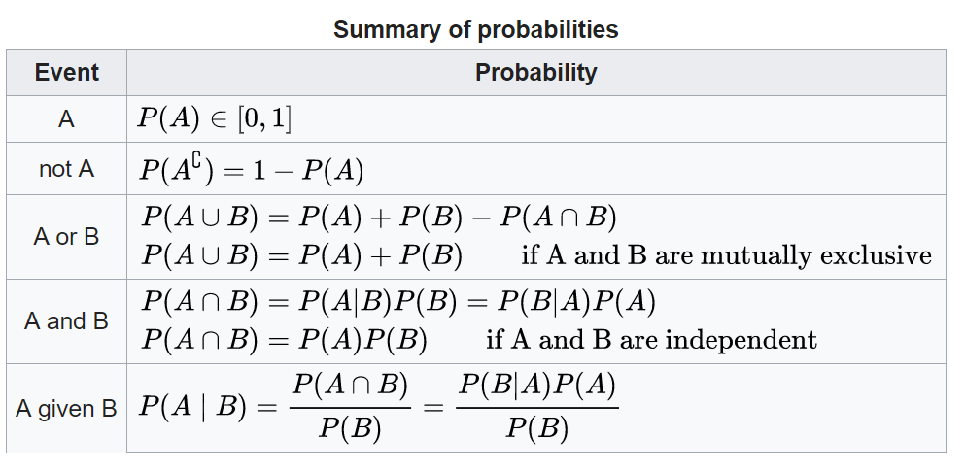

### Statistics

* **Sample** and **Population**
  + Sample size, and Sampling
* **Central Tendency**: In statistics, a central tendency (or measure of central tendency) is a central or typical value for a probability distribution. It may also be called a center or location of the distribution. Colloquially, measures of central tendency are often called averages.

Mean, Median, Mode …

* Error and Standard Error
* Confidence Interval
* Statistical **hypothesis testing** and **p-value**

In statistical hypothesis testing, the p-value or probability value is the probability for a given statistical model that, when the null hypothesis is true, the statistical summary (such as the sample mean difference between two compared groups) would be the same as or of greater magnitude than the actual observed results.

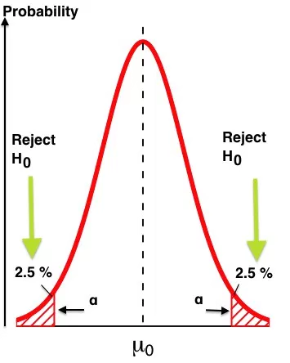 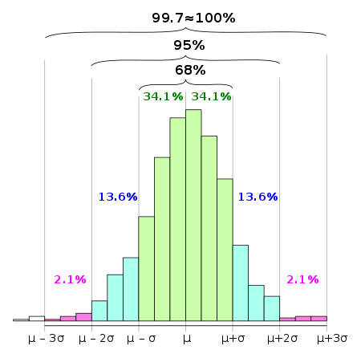

### Distributions

* Histogram is used to
* Distributions
* Gaussian distribution
  + 1 sigma= 68%, 2 sigma = 95%, 3 sigma=99.7%
  + Use ‘Quantile-Quantile Plots’ ‘chi square distribution’ to check….

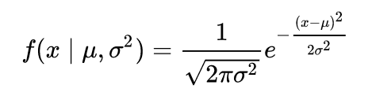

* Poisson distribution

sigma = mean 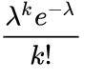

* Other distribution such as gamma, beta,
* i.i.d. (Independent and identically distributed)

### Correlation

* Scatter plot
* Correlation vs Covariance
* Autocorrelation (Time Series)

## Linear Regression Concept and Implementation

### What is Linear Regression?

* In statistics, linear regression is a linear approach for modeling the relationship between a **scalar** dependent variable y and one or more explanatory variables denoted X. The case of one explanatory variable is called simple linear regression
* Old method but still useful approach and computation inexpensive.

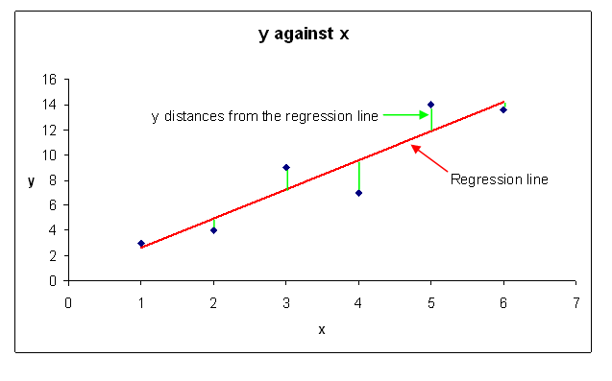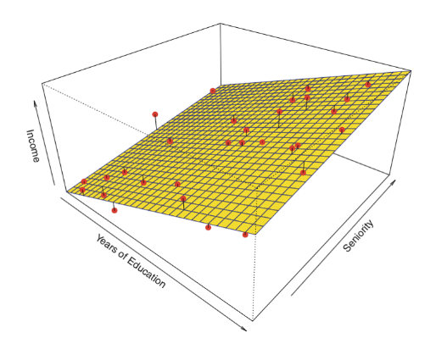

### Assumption

* i.i.d. Independent and identically distributed
* Normal distributed.

Statistical inference

The process of deducing properties of an underlying probability distribution by analysis of data. Inferential statistical analysis **infers** properties about a **population**: this includes **testing** **hypotheses** and **deriving estimates**. The population is assumed to be larger than the observed data set; in other words, the observed data is assumed to be sampled from a larger population.

Estimation

* **OLS** (Ordinary least squares) estimation: is special case of MLS (Max likelihood). Under the additional assumption that the errors are normally distributed, OLS is the maximum likelihood estimator.
* **MLE** (Maximum likelihood estimation): is a method of estimating the parameters of a statistical model given observations, by finding the parameter values that maximize the likelihood of making the observations given the parameters.

### Hat and Hat Function

* Y
* Y-hat
* H

In statistics, the projection matrix sometimes also called the influence matrix or hat matrix.

**Math**:

Suppose that we wish to estimate a linear model using linear least squares. The model can be written as where X is a matrix of explanatory variables (the design matrix), β is a vector of unknown parameters to be estimated, and ε is the error vector.

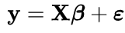

When the weights for each observation are identical and the errors are uncorrelated, the estimated parameters are

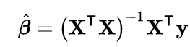

The fitted values are

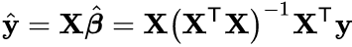

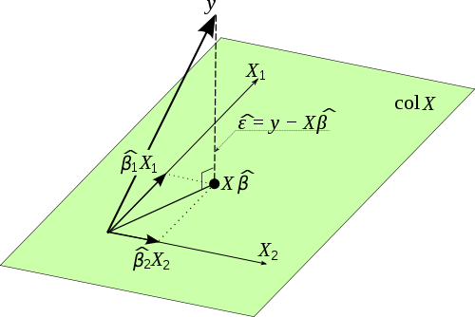

### Implementations in Python:

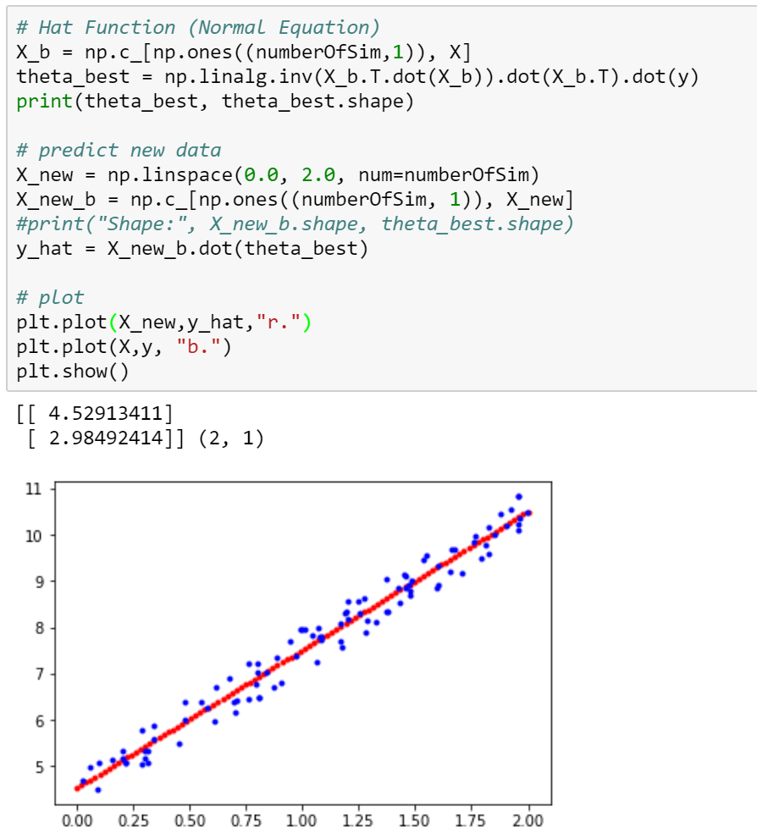

## Introduction to Scikit-learn

Scikit-learn is a free software **machine learning library** for the Python programming language. It features various classification, regression and clustering algorithms including support vector machines, random forests, gradient boosting, and k-means, and is designed to interoperate with the Python numerical and scientific libraries **NumPy** and **SciPy**.

* Simple and efficient tools for data mining and data analysis
* Accessible to everybody, and reusable in various contexts
* Built on NumPy, SciPy, and matplotlib
* Open source, commercially usable - BSD license

### What is the best approach to learn Scikit-learn?

* Too large to remember everything. Learn the **principle** and the design of the library.
* Learn the algorithms, at least high-level concepts.
* Checking the documentation when using it.
* Baby steps. Learn by implementing a simple of machine learning program.

### What is machine learning?

Machine learning is a field of computer science that gives computers the ability to learn without being explicitly programmed.

### Simple Case study

1. Create a model
2. Fit the model
3. Predict data

Code:

#Linear Regression

model = LinearRegression()

model.fit(X, y)

y_hat = model.predict(newX)

### Model evaluation: quantifying the quality of predictions

* sklearn.metrics
* MSE for regression

## Tableau

### Installation

* [**https://www.tableau.com/products/trial**](https://www.tableau.com/products/trial)
* 14 days trial only

### Tableau Files

* tableau workbook .twb
* tableau data source . tds
* tableau bookmark .tbm
* tableau data extract .tde

### Steps for Using Tableau

1. Connect a data source, it could be a CSV file, database connection
2. Drag tables will be used in workbook
3. Take care of the joins of tables.
4. Open the sheet tab and began work on the workbook

# 

## Machine Learning

### Goal

Given data, we want to build predictive tools to answer questions, which can take many forms

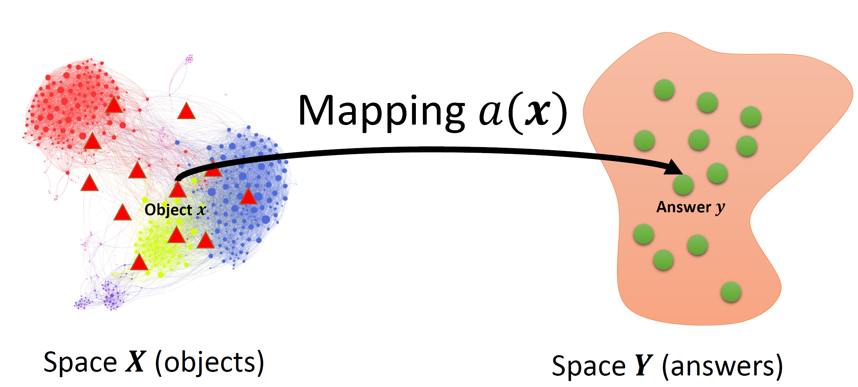

### Limitations

* Finds patterns and insights from the **given data** and thus fails to capture **unknown knowledge**. For example, former CEO of Motorola said based on data and survey people would like to use feature phones but not smartphone.
* Most machine learning models are static after they are trained and fail to handle cases never included in the model. For example, self-driving cars do not know how to make decisions when other cars are doing unexpected behaviors. So a big part of the goal is to generalize well to unseen data

### Types of Learning

#### **Supervised Learning** – with label, training data contains from both 𝑿 and 𝒀

* Classification
* Regression

#### **Unsupervised Learning** – without label, training data comes only from 𝑿

* Clustering
* PCA
* Factor Analysis
* Topic modeling

#### **Reinforcement Learning**

## Variables

* Predictor (labeled X in machine learning convention)

Also called: independent variable, explanatory variable, experimental variable, covariate

* Response (labeled y in machine learning convention)

Also called: dependent variable, outcome variable

## Response Types

* Numeric (e.g. price of a stock)
* Categorical
  + Binary (e.g. wins or loses match, does or does not have cancer)
  + Order (e.g. small, medium, large)
  + No Order (e.g. predicting one of a set of faces from an image)

## Machine learning Models

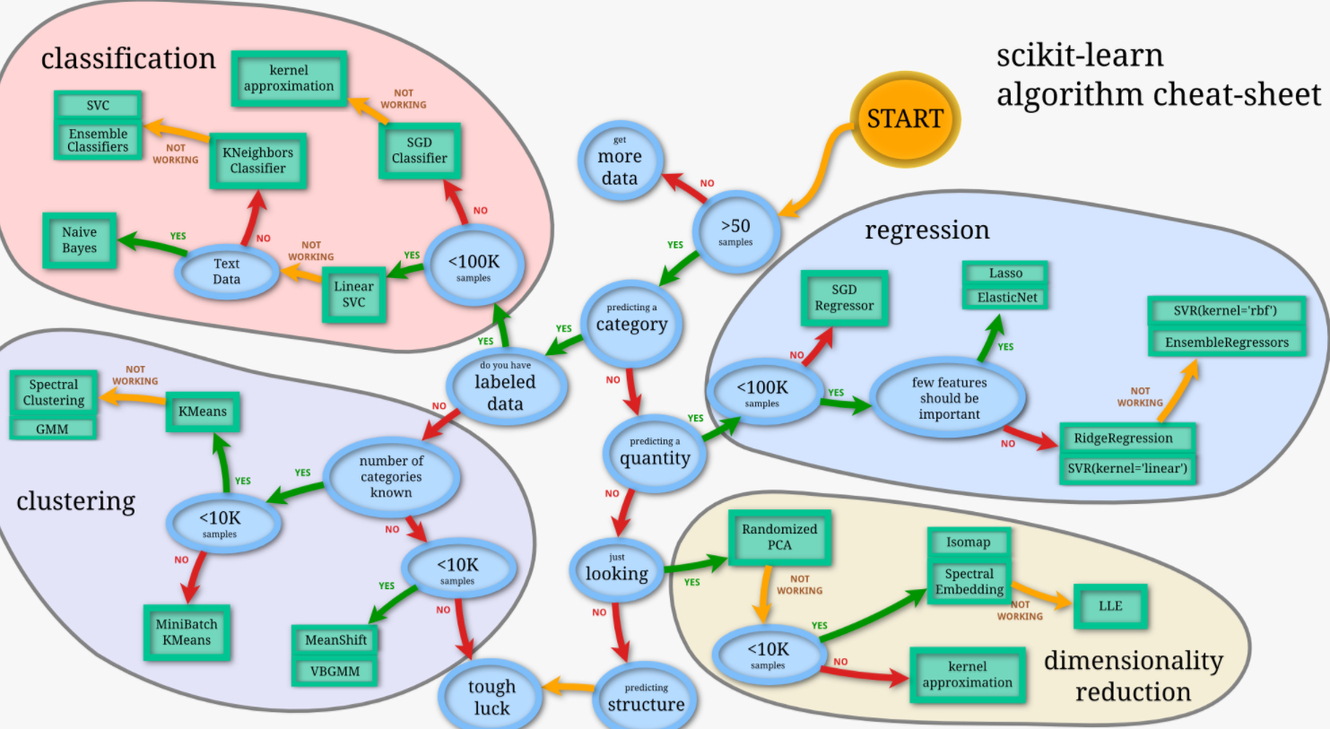

## Compare results

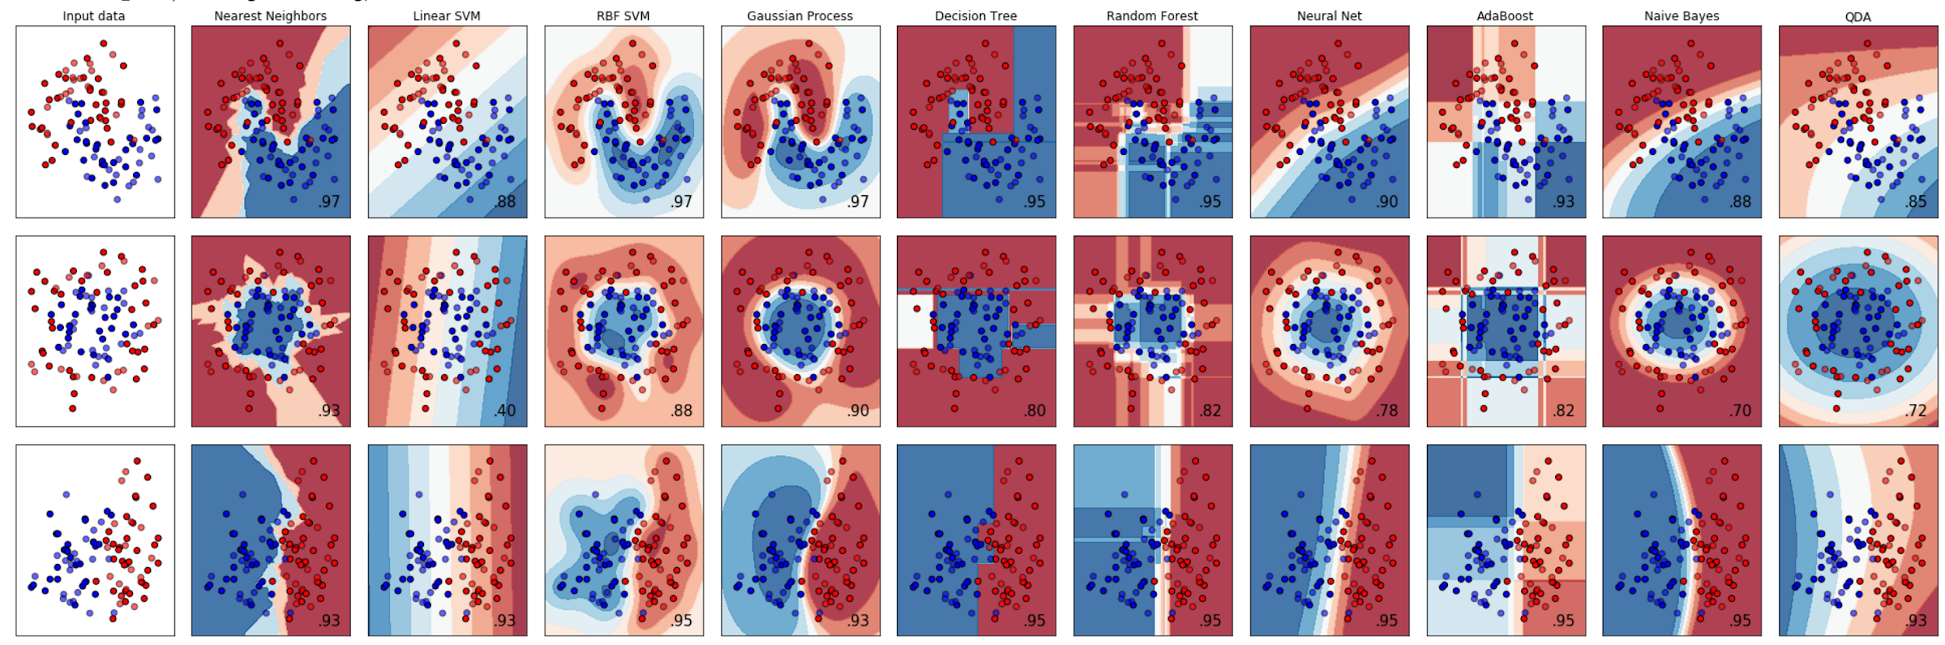 ["Nearest Neighbors", "Linear SVM", "RBF SVM", "Gaussian Process", "Decision Tree", "Random Forest", "Neural Net", "AdaBoost", "Naive Bayes", "QDA"]

## Classification and Regression

### Classification vs Regression

* **Classification** predicts a categorical response
* **Regression** predicts a numerical response

### Linear Regression vs Logistic Regression

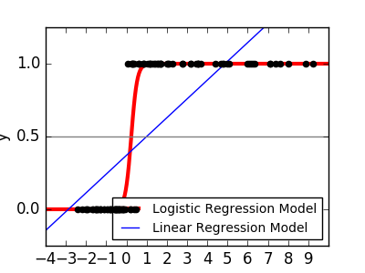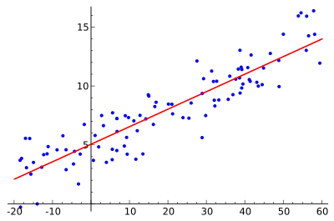

### Link functions

* Why need a link function?
* Logit function and others shape link function

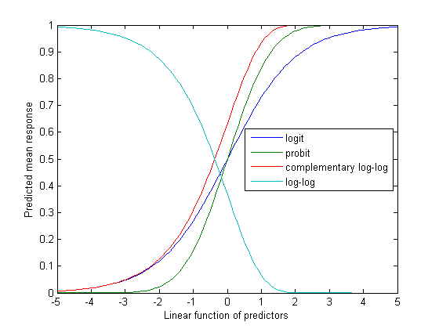

### Model evaluation:

Quantifying the quality of prediction.

* MSE, R2
* Accuracy, Precision, Recall, F1 Store, AUC, Confusion Matrix

## 

## Data Science Process

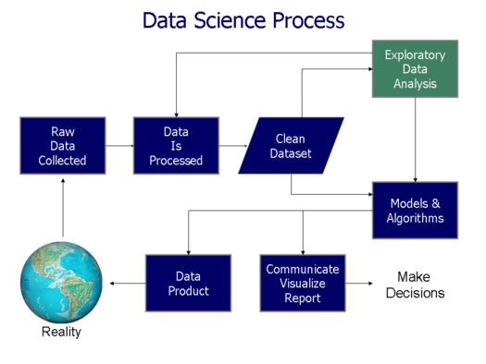

## 

## Scikit-learn in Depth

### The 3 Steps

1. Create a model
2. Fit the model
3. Predict data

Code:

#Linear Regression

model = LinearRegression()

model.fit(X, y)

y_hat = model.predict(newX)

### Pipeline

Pipeline in Scikit-learn is a useful. It **encapsulates** multiple different transformers alongside an estimator into one object.

* **Transformers** are classes that implement both **fit** and (**transform** or **fit_transform**) methods.
* **Estimators** are classes that implement both **fit** and (**predict** or **fit_predict**) methods.

# it takes a list of tuples of Transformers and Estimators

pipeline = Pipeline([

('scaler',StandardScaler()),

('clf', LogisticRegression())

])

# use the pipeline object as a regular classifier

pipeline.fit(X_train,y_train)

### Split Data Set

* Train Test Split
* Using

from sklearn.model_selection import train_test_split

X, y = make_classification(n_samples=100,n_features=10,n_informative=2)

X_train, X_test, y_train, y_test = train_test_split( X, y, test_size=0.33, random_state=42)

### Model evaluation:

* Regression problem or Classification problem?
* Using **sklearn.metrics** such as

accuracy_score(y_test,y_preds)

## KNN

K-nearest neighbors algorithm (k-NN) is a non-parametric method used for classification and regression. In both cases, the input consists of the k closest training examples in the feature space.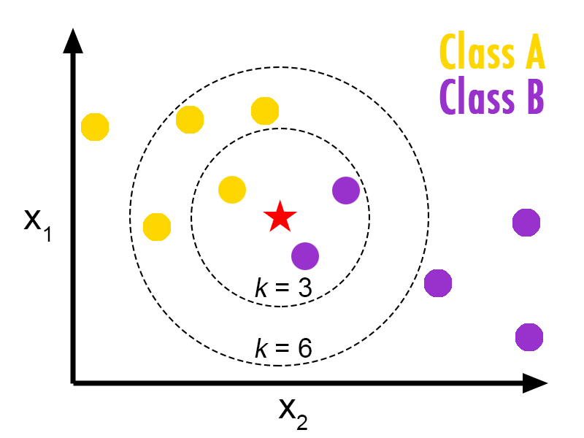

**Good**

* No assumptions
* No training time
* Can do non-linear

**Bad**

* speed

## 

## Decision Tree

Decision tree is a decision support tool that uses a tree-like graph or model of decisions and their possible consequences, including chance event outcomes, resource costs, and utility. It is one way to display an algorithm that only contains conditional control statements.

To create the decision tree for a classification problem, the decision rules generated by training data according to purity.

Impurity measured by two ways:

1. Gini Index
2. Entropy

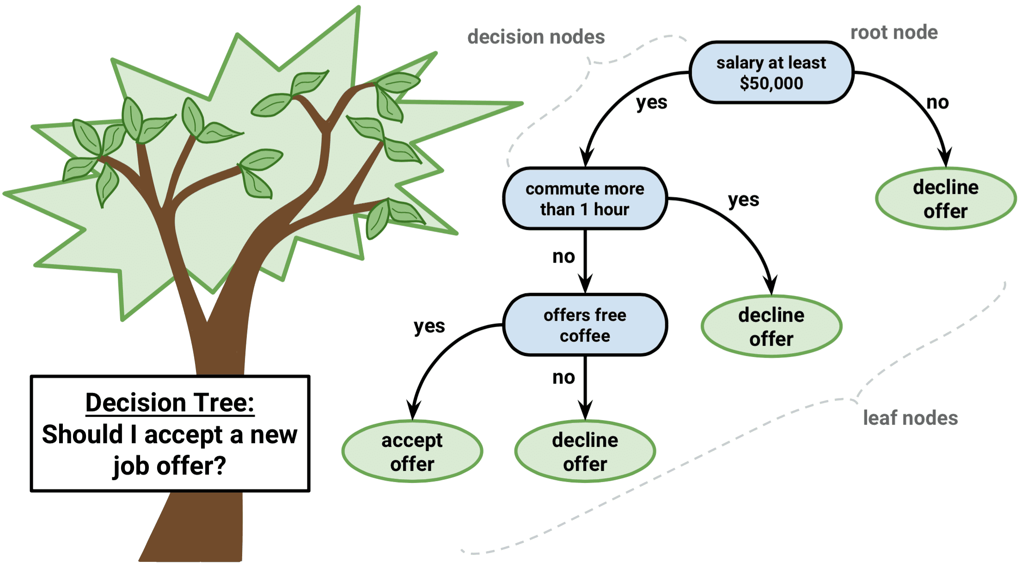

**Overfitting**

* Generalization
* Bias & Variance Trade-Off

## Random Forest

Random forests or random decision forests are an ensemble learning method for classification, regression and other tasks, that operate by constructing a multitude of decision trees at training time and outputting the class that is the mode of the classes (classification) or mean prediction (regression) of the individual trees. Random decision forests correct for decision trees' habit of overfitting to their training set.

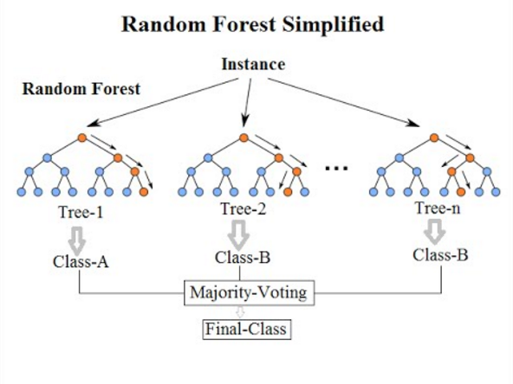

## SVM

A Support Vector Machine (SVM) is a discriminative classifier formally defined by a separating hyperplane. In other words, given **labeled** training data (supervised learning), the algorithm outputs an optimal hyperplane which categorizes new examples.

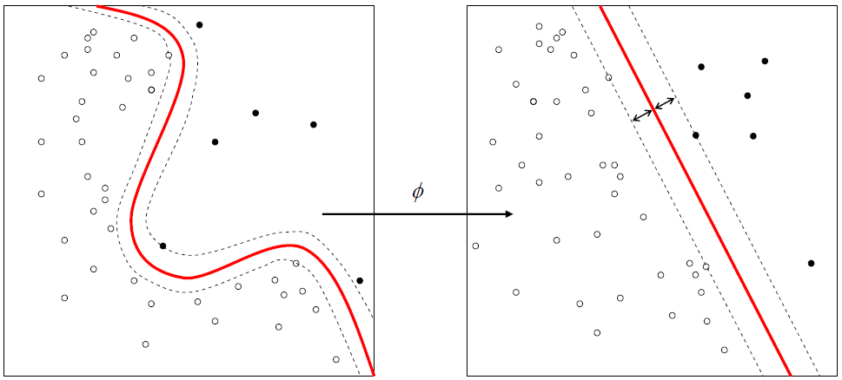

## NLP

Natural-language processing (NLP) is a field of computer science, artificial intelligence concerned with the interactions between computers and human (natural) languages, and, in particular, concerned with programming computers to fruitfully process large natural language data.

### nltk package

* import nltk
* To use this package, need to run this function download dictionaries. It will take some time, and python will open the NLTK downloader for the first time.  
  **nltk.download()**

### Textblob package

* **pip install --user textblob**
* from textblob import TextBlob

### Steps of preprocessing raw text data

1. Get data. (from web service, web site, files, database)
2. Parse Data using Regular expression(RE).
3. Prepare Raw text
4. Tokenize
5. Clean words
6. Remove stop words
7. Lemma or Stem (use Lemmatizer for better results)

Sample code of preprocessing data

# Token Raw text

raw_words = nltk.word_tokenize(raw)

# Clean words

words = [word for word in raw_words if len(word) > 1]

words = [word for word in words if w.isalnum()]

words = [w.lower() for w in words if word.isalpha()]

# Stop words

stopwords = set(nltk.corpus.stopwords.words('english'))

words = [word for word in words if word not in stopwords]

# Lemma or Stem; use Lemmatizer for better results

wnl = nltk.WordNetLemmatizer()

cleaned_words = [wnl.lemmatize(t) for t in words]

### n-gram

n-gram is a contiguous sequence of n items from a given sample of text or speech. The items can be phonemes, syllables, letters, words or base pairs according to the application. The n-grams typically are collected from a text or speech corpus.

* Capture the context of the text
* Use moving window to get the n-gram
* n-gram has been implemented by nltk
  + nltk.bigrams()
  + nltk.trigrams()
* using nltk.FreqDist to get **frequency** of givendictionary

### TF-IDF

TF-IDF, short for term frequency–inverse document frequency, is a numerical statistic that is intended to reflect how important a word is to a document in a collection or corpus.

* term frequency
* inverse document frequency

### POS Tagging

POS Tagging = Assigning word class information to words

Such as

|  |  |  |  |  |
| --- | --- | --- | --- | --- |
| the | man | bought | a | book |
| determiner | noun | verb | determiner | noun |

Libraries

* textblob <http://textblob.readthedocs.io>
* nltk.pos_tag()

### NER - Named Entity Recognition

The task of identifying proper names of people, organizations, locations, or other entities is a subtask of information extraction from natural language documents.

### man analyzing the sentiment of an article

### Sentiment Analysis

Sentiment Analysis is the process of determining whether a piece of writing is positive, negative or neutral. It’s also known as opinion mining, deriving the opinion or attitude of a speaker. A common use case for this technology is to discover how people feel about a particular topic.

### 

### Topic Models

Topic model is a type of statistical model for discovering the abstract "topics" that occur in a collection of documents. Topic modeling is a frequently used text-mining tool for discovery of hidden semantic structures in a text body.

## Financial

### Time Series

A time series is a series of data points indexed in time order. Most commonly, a time series is a sequence taken at successive equally spaced points in time. Thus, it is a sequence of discrete-time data.

In Python the Pandas Series object is designed to handle Time Series data

### Financial API

Quandl is a marketplace for financial, economic and alternative data delivered in modern formats for today's analysts, including Python, Excel, Matlab, R, and via our API.

* <https://www.quandl.com/>
* Import # quandl for financial data import quandl
* Need to register to get the api key
* Python can directly use it

quandl.ApiConfig.api_key = 'cd5MY1y2uuHAizhbGyxi'

# Retrieve bitcoin data from Quandl

bitcoin = quandl.get('BCHARTS/BITSTAMPUSD')

# Retrieve the GM data from Quandl

gm = quandl.get('WIKI/GM')

plt.plot(gm.index, gm['Adj. Close'])

plt.title('GM Stock Price')

plt.ylabel('Price ($)');

plt.show()

plt.plot(bitcoin.index, bitcoin['Weighted Price'], 'r')

plt.title('Tesla Stock Price')

plt.ylabel('Price ($)');

plt.show();

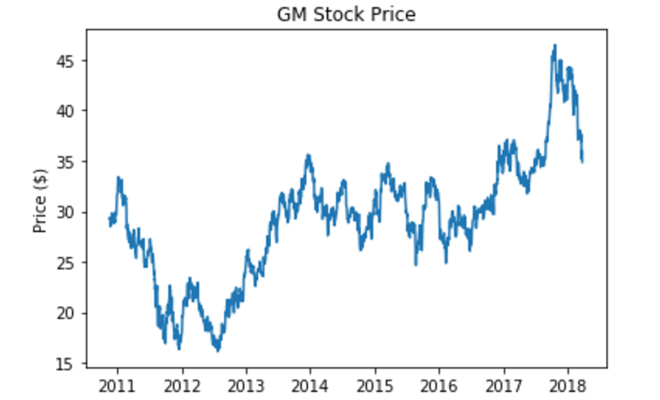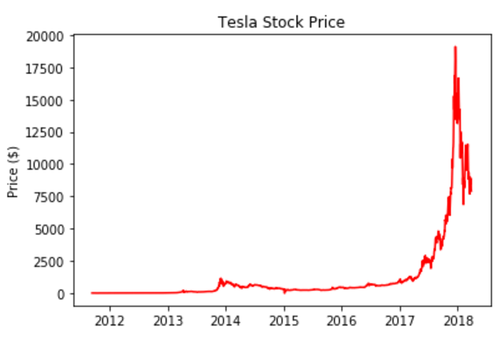

### Predicting Models

* Additive models
* RNN models

## Unsupervised Learning

Unsupervised learning is a type of machine learning algorithm used to draw inferences from datasets consisting of input data **without labeled responses**.

### Clustering

The most common unsupervised learning method is cluster analysis, which is used for exploratory data analysis to find hidden patterns or grouping in data. The clusters are modeled using a measure of similarity which is defined upon metrics such as Euclidean or probabilistic distance.

### Common clustering algorithms:

* **k-Means clustering**: partitions data into k distinct clusters based on distance to the centroid of a cluster
* **Hierarchical clustering**: builds a multilevel hierarchy of clusters by creating a cluster tree
* **Gaussian mixture models**: models clusters as a mixture of multivariate normal density components
* **Self-organizing maps**: uses neural networks that learn the topology and distribution of the data
* **Hidden Markov models**: uses observed data to recover the sequence of states
* **Manhattan Distance**: The distance between two points in a grid based on horizontal and/or vertical path

### K-means

The [**K Means**](http://scikit-learn.org/stable/modules/generated/sklearn.cluster.KMeans.html#sklearn.cluster.KMeans) algorithm clusters data by trying to separate samples in n groups of equal variance, minimizing a criterion known as the [inertia](http://scikit-learn.org/stable/modules/inertia) or within-cluster sum-of-squares. This algorithm requires the number of clusters to be specified. It scales well to large number of samples and has been used across a large range of application areas in many different fields.

The k-means algorithm divides a set of  samples  into  disjoint clusters , each described by the mean  of the samples in the cluster. The means are commonly called the cluster “centroids”; note that they are not, in general, points from , although they live in the same space. The K-means algorithm aims to choose centroids that minimize the *inertia*, or within-cluster sum of squared criterion:

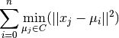

from sklearn.cluster import KMeans

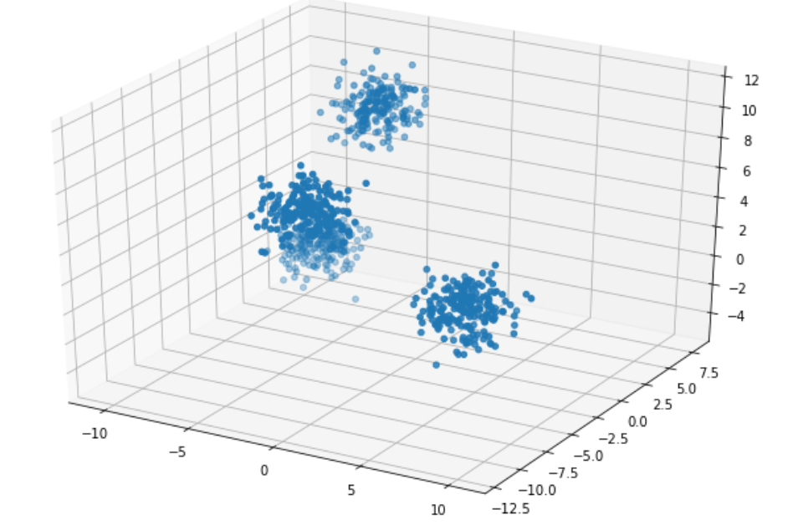 -----> 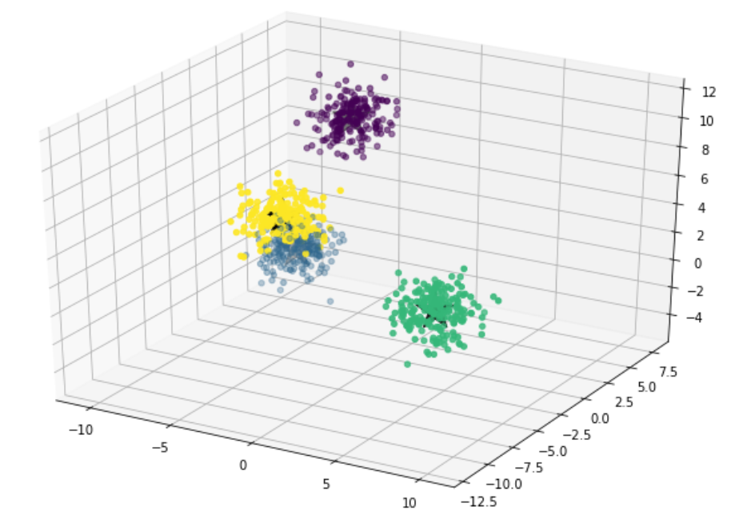

### Hierarchical clustering

Hierarchical clustering is a general family of clustering algorithms that build nested clusters by merging or splitting them successively. This hierarchy of clusters is represented as a tree (or dendrogram). The root of the tree is the unique cluster that gathers all the samples, the leaves being the clusters with only one sample.

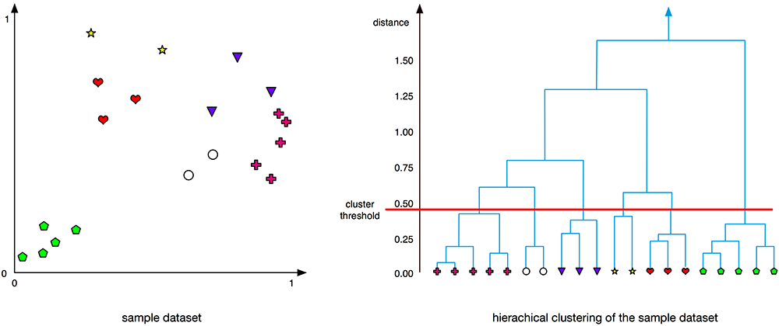

### PCA

Principal component analysis (PCA) is a statistical procedure that uses an **orthogonal transformation** to convert a set of observations of possibly correlated variables into a set of values of linearly uncorrelated variables called **principal components**.

* The number of distinct principal components is equal to the smaller of the number of original variables or the number of observations minus one.
* **first principal component** has the **largest** possible **variance**.
* Each succeeding component in turn has the highest variance possible under the **constraint** that it is **orthogonal to the preceding components**.
* The resulting vectors are an **uncorrelated** orthogonal basis set.

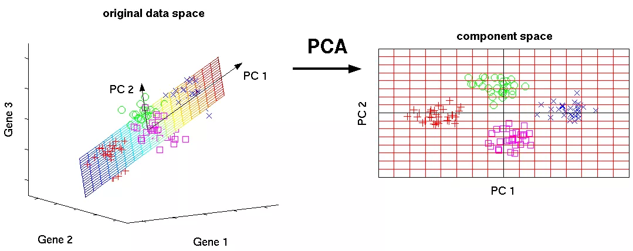

### Factor Analysis

Factor Analysis is a method for modeling **observed variables**, and their covariance structure, in terms of a smaller number of underlying **unobservable (latent) factors**.

Factor analysis is generally an exploratory/descriptive method that requires many **subjective judgments**. It is a widely used tool and often **controversial** because the models, methods, and subjectivity are so flexible that debates about interpretations can occur.

### Topic Model

One useful NLP algorithm. It is a unsupervised learning algorithm.

## Introduction to Neural Networks and Deep Learning

Neural networks are a beautiful **biologically-inspired** programming paradigm which enables a computer to learn from observational data.

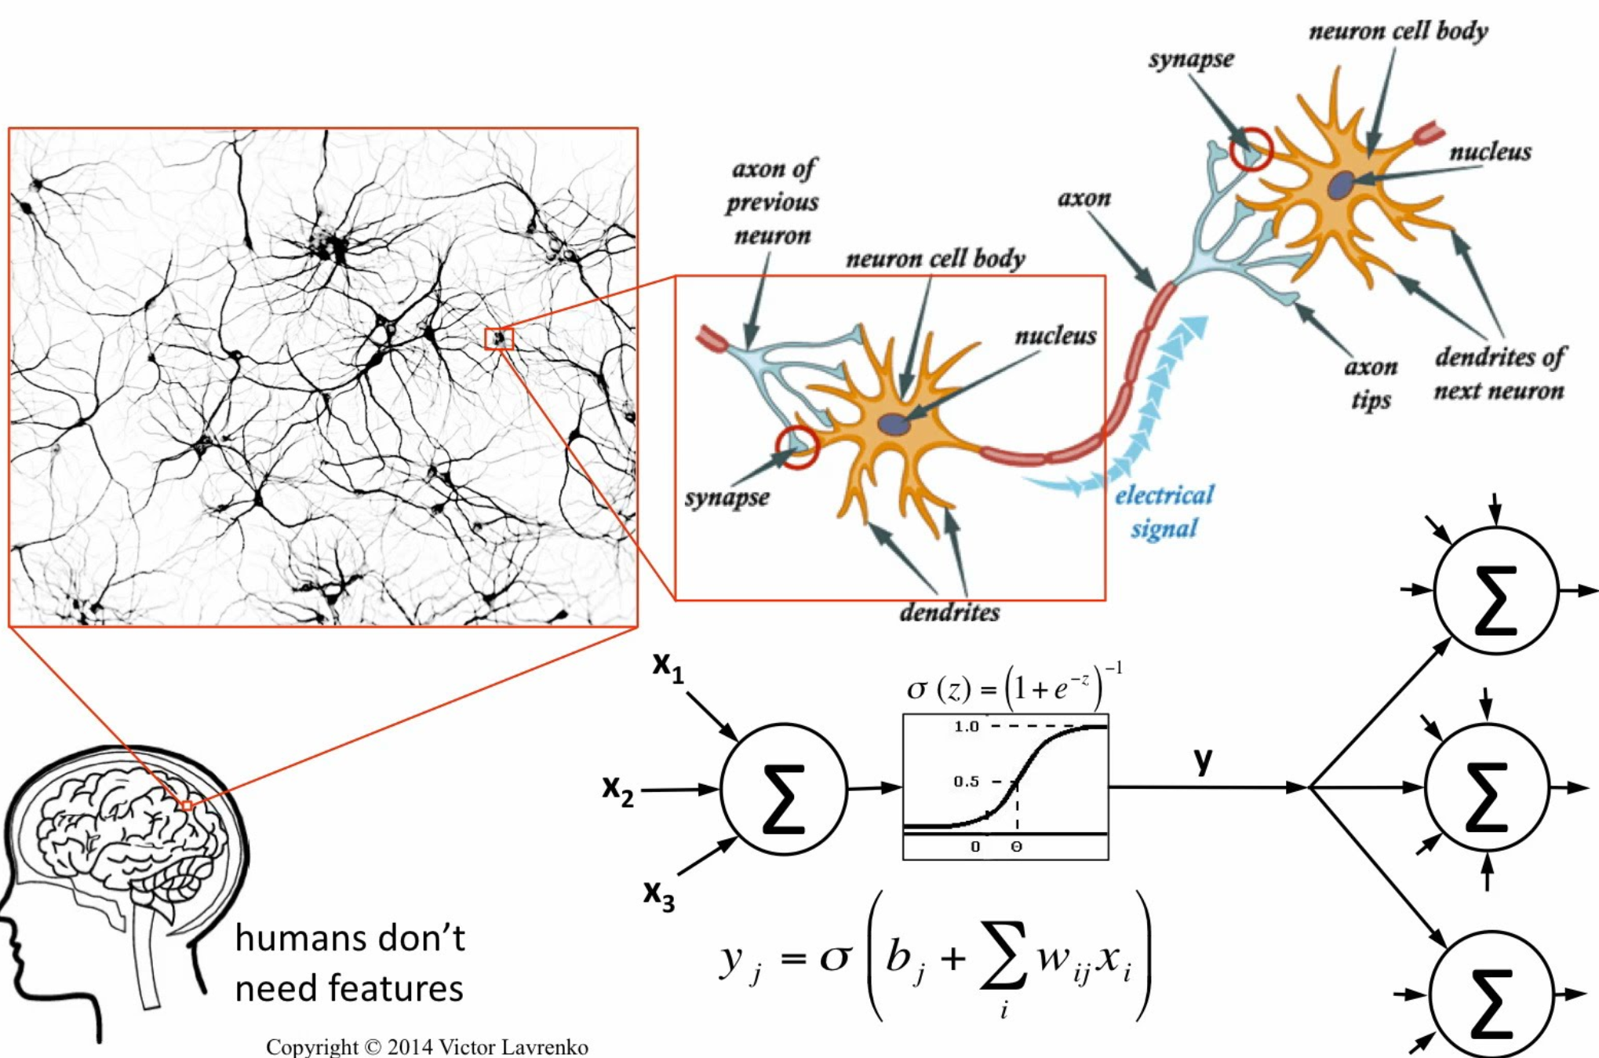

### Components of Artificial Neural Networks

Three kinds of Layers

* Input Layer
* Hidden Layers
* Output Layer

Every Layer has only one activation function.

* softmax
* ReLue including eRelu
* tanh

Weights,

* Note as w, they will be calculated during training step using **backpropagation**.

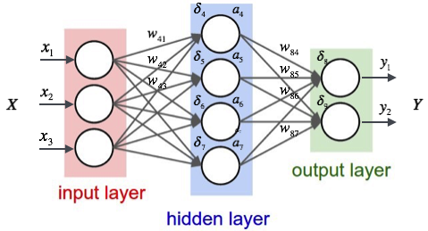

### Biological Neuron vs Artificial Neuron

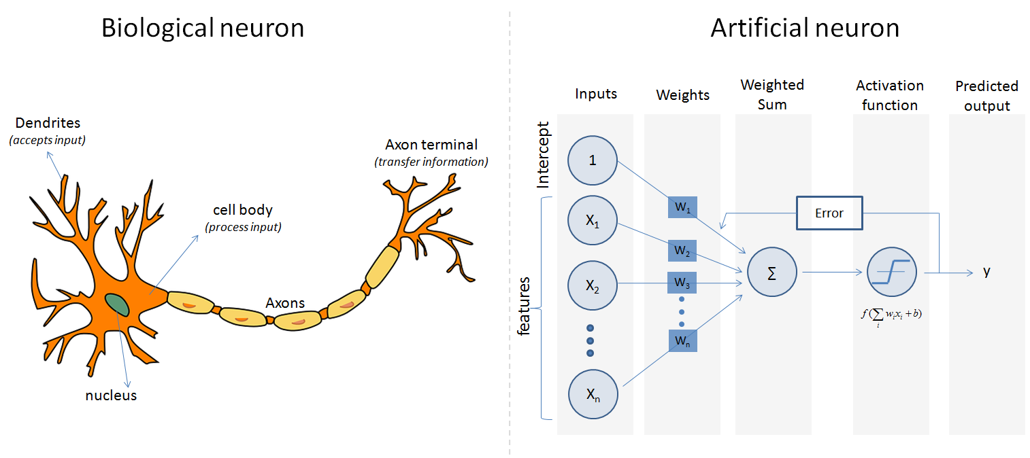

### Sklearn Implementation

Multilayer Perceptron Classifier

#Sklearn

from sklearn.neural_network import MLPClassifier

# Week 10 - Capstone

This week is primarily reserved for students to work on their personal Capstone projects. Each student will present their project to potential employers during the student showcase week.

## Language R

R is a programming language and software environment for statistical analysis, graphics representation and reporting.

### Setup

* R language http://www.r-project.org/index.html
* R-Studio
* Setup work directory

> getwd()

> setwd(‘path_a\path_b’)

### Packages

* Install packages

> install.packages("dplyr")

### Read and Write data

* read_csv(path)
* write_csv(x, path)

### Language basic

#### Data Type (4 types)

* Numeric (Int, Double…)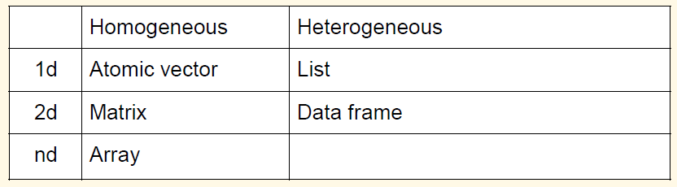
* Complex
* Logical
* Character

#### Data Structure (6 Structures)

* **Vector** - Vectors consist of a set of scalars and can be generated by the function c().
* **Matrix** - There are two methods to generate a matrix in R. One is to use the function **matrix**() The other is to **combine** (such as **cbind**, **rbind**) several vectors or several matrices.
* **List** - A list is a set of vectors or matrices combined in a single object. We can generate a list in R by using the function list().
* **Dataframe** - A data frame is a kind of list. More precisely, a data frame is a list of items with the same structure.
* **Array** - can store data more than two dimensions.
* **Factor** - Factor is a type used for **categorizing** elements.

#### Data Structure/type Investigation Functions

* typeof()
* mode() Represents how an object is stored in memory
* class() Represents the object’s abstract type
* str() Human readable description of any R data structure
* head(a_data) tail(a_data)
* length()

### Control Flow

* If-statement
* For-statements
* While-statements

### Functions

#### Syntax

An R function is created by using the keyword function. The basic syntax of an R function definition is as follows

function_name <- function(arg_1, arg_2, ...) {

Function body

}

* Function Name - It is stored in R environment as an object with this name.
* Arguments - Arguments are placeholder. When a function is invoked, you pass a value to the argument. Arguments are optional. Arguments can have default values. No Type Statements.
* Function Body
* Return Value - The return value of a function is the last expression in the function body to be evaluated.

#### Built-in Function

Simple examples of in-built functions are seq(), mean(), max(), sum(x) and paste(...) etc. Do **NOT** **overwrite** these functions.

#### User-defined Function

We can create user-defined functions in R. They are specific to what a user wants and once created they can be used like the built-in functions.

# Create a function to print squares of numbers in sequence.

new.function <- function(a) {

for(i in 1:a) {

b <- i^2

print(b)

}

}

### Apply functions

Due to performance issue, dealing with large data and iterating it, for/while loop is not advised.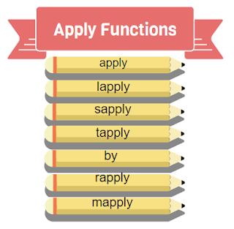

#### apply()

The base function. It applies on matrix, and it takes 3 arguments

* data matrix
* row/column operation, – 1 for row wise operation, 2 for column wise operation
* function to be applied on the data.

#### lapply()

Applied for operations on list objects

* It returns a list object of same length of original set
* Each element of the return is the result of applying FUN to the corresponding element of list.

#### sapply()

* Wrapper class to lapply with difference being **it returns vector** or **matrix** instead of list object.
* More frequently used than lapply()

#### tapply()

A very powerful function that lets you break a vector into pieces and then apply some function to each of the pieces.

#### by()

by works similar to group by function in SQL, applied to factors, where in we may apply operations on individual results set.

#### rapply():

rapply() is a recursive version of lapply.

#### mapply():

mapply is a multivariate version of sapply.

### Visualization

* plot
* hist
* pie
* boxplot
* par(mfrow = c(2, 2))

## Random and Distribution

### What is random

Randomness is the lack of pattern or predictability in events. A random sequence of events, symbols or steps has no order and does not follow an intelligible pattern or combination.

### Distributions

* Normal Distribution
* Binomial Distribution
* Poisson Distribution
* Uniform Distribution
* Beta Distribution

### Mean, Median & Mode

Used to measure Central Tendency.

The term central tendency refers to the "middle" value or perhaps a typical value of the data, and is measured using the mean, median, or mode. Each of these measures is calculated differently, and the one that is best to use depends upon the situation.

### r d p q functions

* d is density function (**pdf,** or **pmf**)
* p is cumulative probability function (**pcf**)
* q is quant function, or inverse function (**inverse** **pcf**)
* r is the random function, and it generates random sequences

dnorm(x, mean, sd)

pnorm(x, mean, sd)

qnorm(p, mean, sd)

rnorm(n, mean, sd)

dbinom(x, size, prob)

pbinom(x, size, prob)

qbinom(p, size, prob)

rbinom(n, size, prob)

dpois(x, lambda)

ppois(q, lambda)

qpois(p, lambda)

rpois(n, lambda)

dunif(x, min = 0, max = 1)

punif(q, min = 0, max = 1)

qunif(p, min = 0, max = 1)

runif(n, min = 0, max

### Simulation example

par(mfrow = c(2, 2))

x <- seq(-5, 5, by = .1)

y <- dnorm(x, mean = 0, sd = 1)

plot(x,y, type='l')

yc <- pnorm(x, mean = 0, sd = 1)

plot(x,yc, type='l')

#simulation

norm_rands = rnorm(1000,mean=0, sd=1)

plot(norm_rands)

hist(norm_rands)

## Ecommerce Implementation

### Database design using Entity-Relationship (ER) Model

Entity Relationship Diagram. An entity relationship model, also called an entity-relationship (ER) diagram, is a graphical representation of entities (which will become your tables) and their relationships to each other. Database modeling is the process of creating a data model.

### Diagram



* Entity
  + Strong entities - exist independently from other entity types
  + Weak entities - depend on some other entity type
  + Associative entities - associate the instances of one or more entity types
* Relationship, Recursive Relationship
* Attribute, Primary Key, Composite Attribute, Multi-valued Attribute, Derived Attribute

### Map



### Ideas of business logic implementation

* Feature isolation:
* Action Mapping: Saved updated states to data persistence layer
* URL based logic, not UI based

### Shopping cart database design

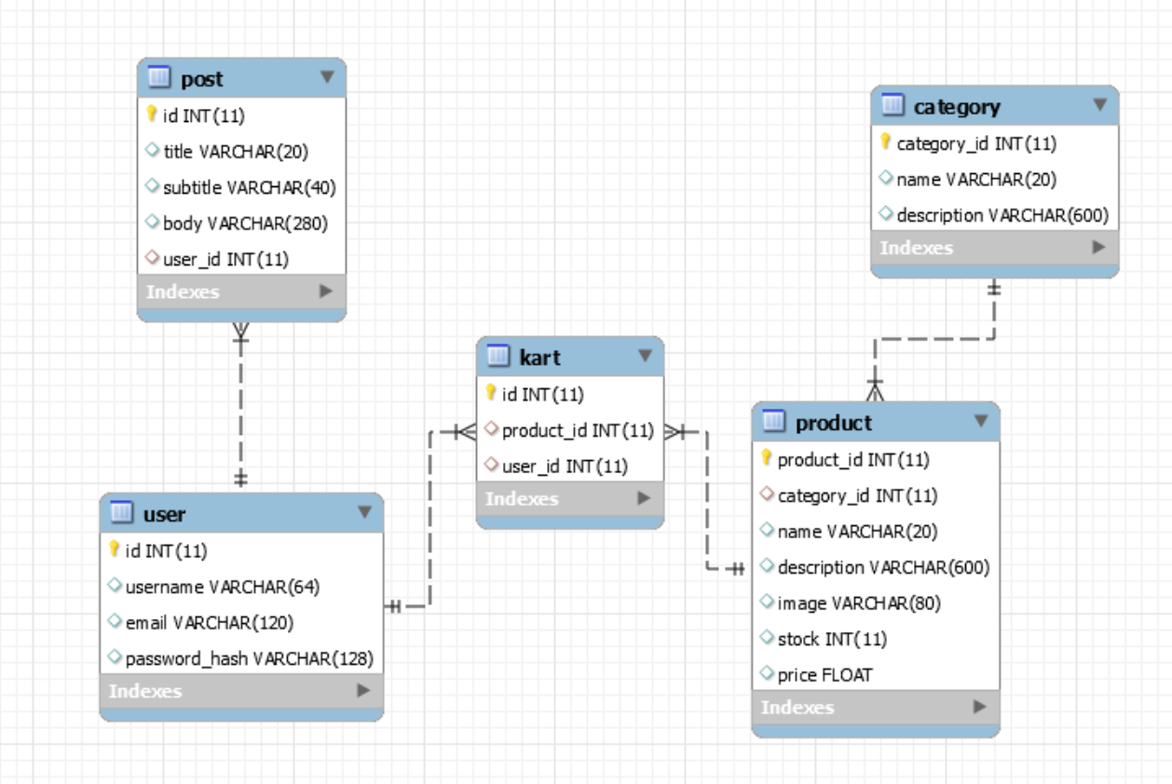

### Shopping cart database Implementation

URL based logic

@app.route('/store')

@app.route('/products')

def products():

@app.route('/product/<int:product_id>')

def product(product_id):

@app.route("/cart")

def cart():

@app.route("/addToCart/<int:product_id>/<string:from_page>")

def addToCart(product_id, from_page):

@app.route("/removeFromCart/<int:product_id>/<string:from_page>")

def removeFromCart(product_id, from_page):

## Domain name and DNS

### DNS

The Domain Name System is a hierarchical decentralized naming system for computers, services, or other resources connected to the Internet or a private network.

### Personal GitHub site custom domain

website

* Buy a domain name at godaddy.com for 1 $ a year.
* Open terminal input> **nslookup** xxx.github.io
* Open DNS Management and update the DNS

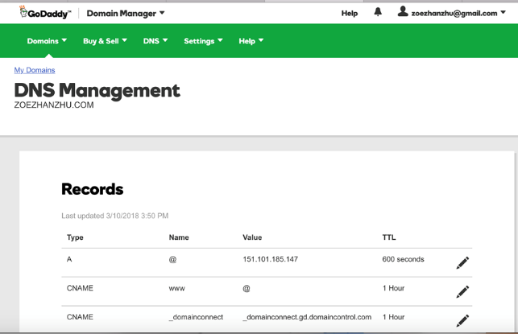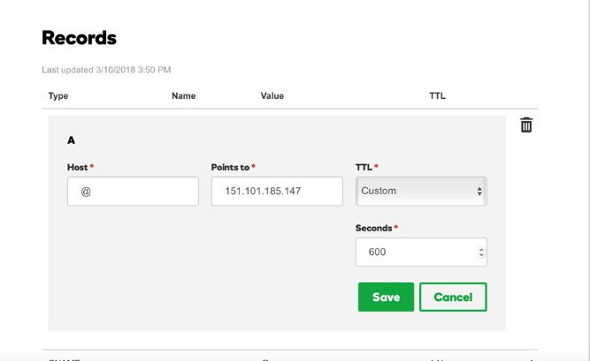

* Go back GitHub profile and go to the Repo Setting. Update custom domain to the domain you just purchased.
* Please pull change to your local repo.
* Try the domain at bowers.

## Spark

Apache Spark is a fast and general engine for **big data processing**, with built-in modules for **streaming**, **SQL**, **machine learning** and **graph processing**.

### Components

Spark powers a stack of libraries including **SQL and DataFrames**, **MLlib** for machine learning, **GraphX**, and **Spark Streaming**.

Spark is high performance engine.

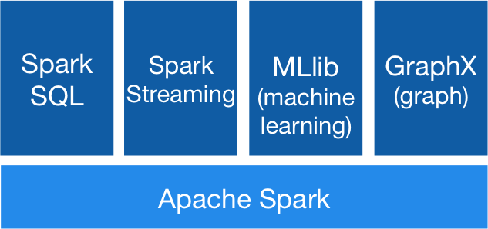 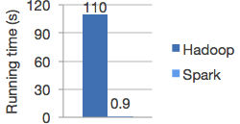

### Development setup

* Go to <https://databricks.com/try-databricks>
* Setup COMMUNITY EDITION account
* Create a free cluster
* Open a python notebook and began working on Spark
* Input > spark and check if the environment is setup, it will display **spark session**

Out[1]: <pyspark.sql.session.SparkSession at 0x7fe226cce410>

### RDD

Spark revolves around the concept of a resilient distributed dataset (RDD), which is a fault-tolerant collection of elements that can be operated on in parallel.

#### Two ways to create RDDs

* Parallelizing an existing collection in your driver program

data = [1, 2, 3, 4, 5]

distData = sc.parallelize(data)

* Referencing a dataset in an external storage system, such as a shared filesystem, HDFS, HBase, or any data source offering a Hadoop InputFormat

data_from_file = sc.textFile('/Users/drabast/Documents/PySpark_Data/data_key.txt', 4)

#### Two RDD Operations

* Transformations
* Actions

### SQL and DataFrame

A DataFrame is a Dataset organized into **named columns**.

* It is conceptually equivalent to a table in a relational database or a data frame in R/Python, but with richer optimizations under the hood.
* DataFrame can be constructed from a wide array of sources such as: structured data files, tables in Hive, external databases, or existing RDDs.
* The DataFrame API is available in Scala, Java, Python, and R. In Scala and Java, a DataFrame is represented by a Dataset of Rows.

#### Create DataFrame

DataFrame can be created from an existing **RDD**, from a Hive **table**, or from Spark data sources, or a json file.

# Create DataFrame

swimmersJSON = spark.read.json(stringJSONRDD)

swimmersJSON.show()

#### Query

Query can be programing based or sql based.

# Query id and age for swimmers with age = 22 in SQL

spark.sql("select id, age from swimmers where age = 22").show()

# Query id and age for swimmers with age = 22 via DataFrame API

swimmers.select("id", "age").filter("age = 22").show()

### Spark machine learning

The goal of Spark’s machine learning (ML) library is to make practical machine learning scalable and easy. At a high level, it provides tools such as:

* ML Algorithms: common learning algorithms such as classification, regression, clustering, and collaborative filtering
* Featurization: feature extraction, transformation, dimensionality reduction, and selection
* Pipelines: tools for constructing, evaluating, and tuning ML Pipelines
* Persistence: saving and load algorithms, models, and Pipelines
* Utilities: linear algebra, statistics, data handling, etc.

There are another Spark machine learning api, it called MLlib RDD-based API is now in maintenance mode. The RDD-based API is expected to be removed in Spark 3.0. Do not work on it now!

## Recommendations

### Data Science and computer Science Reading List

* An Introduction to Statistical Learning: with Applications in R (Springer Texts in Statistics)
* Python for Data Analysis: Data Wrangling with Pandas, NumPy, and IPython
* Hands-On Machine Learning with Scikit-Learn and TensorFlow: Concepts, Tools, and Techniques to Build Intelligent Systems 1st Edition
* Secrets of the JavaScript Ninja 2nd Edition
* Practical Statistics for Data Scientists: 50 Essential Concepts

### Sites

<https://www.kaggle.com/competitions>

<https://leetcode.com/>

<https://www.kaggle.com/learn/overview>

<https://chrisalbon.com/>